# From Climate Change to Civil Unrest

Fang Jin, Wei Wang,

Fang Jin. Discover Analytics Center, Department of Computer Science, Virginia Tech, Arlington, VA 22203, USA (e-mail: jfang8@vt.edu).

Wei Wang. Department of Computer Science, Northern Virginia Center, Virginia Tech, Falls Church, VA 22043, USA (e-mail: wwang15@vt.edu).

## Abstract

*Climate change is taking place everywhere, temperatures are rising, icecaps and glaciers are melting and extreme weather events are becoming more frequent and more intense. Climate change may drive different forms of conflicts in different regions of the world, for instance, conflict over resources, economic damage, lack of energy supply, pressure on government, etc.. This paper did quantity analysis of the protest caused by climate change, and identify its evolution pattern from climate change to civil unrest, also present the climate change events influence in social media.*

## Introduction

The environmental changes from climate change can have important effects on our well-being and security. Reduction of arable land, widespread shortage of water, diminishing food and fish stocks, increased flooding and prolonged droughts are already happening in many parts of the world. A drop in agricultural productivity will lead to, or worsen, food-insecurity in least developed countries and an unsustainable increase in food prices across the board. Water shortage in particular has the potential to cause civil unrest and to lead to significant economic losses. Those parts of the populations that already suffer from poor health conditions, unemployment or social exclusion are rendered more vulnerable to the effects of climate change, which could amplify or trigger migration within and between countries. Climate change may significantly increase instability in weak or failing states by over-stretching the already limited capacity of governments to respond effectively to the challenges they face. One of the most significant potential conflicts over resources arises from intensified competition over access to, and control over, energy resources. That in itself is, and will continue to be, a cause of instability.

While it is unlikely that the physical impacts of climate change will have a direct effect on conflict, there are a number of plausible causal mechanisms that run through intermediate variables, such as population exposure and human health, economic growth, institutional capacity and governance, and other known conflict predictors. Additionally, there is growing consensus that the anticipated physical effects of climatic changes will have serious implications for human wellbeing and security, but quantitative efforts to assess how the impacts will influence the future probability of armed conflict is relatively limited. If the impact of climate change is going to make regions of violence poorer, then they really provide a level of fertility for inciting disaffection, resentment against the prosperous world. It’s likely that physical and economic disruptions resulting from climate change could heighten tensions in sensitive areas of the world. That’s an indirect effect that can create the conditions for terrorism. However, what is the interaction between climate change and civil unrest, how the climate change evolves into social movements, is still unclear. Improving the understanding of these dynamics as well as developing the mechanism of identify the climate related civil unrest events, is critical for developing interventions and adaptations to mitigate these risks.

## Overview Results

#### K Nearest Neighbors - Classification

Text classification is a process of grouping text documents into one or more predefined categories based on their content. The first step in text categorization is to transform documents, which typically are strings of characters, into a representation suitable for the learning algorithm and the classification task. The most commonly used document representation is the so-called vector space model. In this model, each document is represented by a vector of words. A word-by-document matrix A is used for a collection of documents, where each entry represents the occurrence of a word in a document, i.e., A = (a*ij*), where a*ij* is the weight of word i in document j. Let f*ij*be the frequency of word *i* in document *j*, *N* the number of documents in the collection, *M* the number of distinct words in the collection, and n*i* the total number of times word *i* occurs in the whole collection. A common weighting approach is the so-called *tf* *idf* (term frequency - inverse document frequency) weighting:

A*ij =* f*ij* x log(N/n*i*)

To classify a class-unknown document ***X***, the *k*-Nearest Neighbor classifier algorithm ranks the document's neighbors among the training document vectors, and uses the class labels of the *k* most similar neighbors to predict the class of the new document. The classes of these neighbors are weighted using the similarity of each neighbor to ***X***, where similarity is measured by Euclidean distance or the cosine value between two document vectors [3].

KNN has been used in statistical estimation and pattern recognition already in the beginning of 1970’s as a non-parametric technique. A case is classified by a majority vote of its neighbors, with the case being assigned to the class most common amongst its K nearest neighbors measured by a distance function. If K = 1, then the case is simply assigned to the class of its nearest neighbor. Choosing the optimal value for K is best done by first inspecting the data.

We first manually identify 100 climate-related protest events as the training sets. In our protest filter design, text similarity measures play a fundamentally important, where apply Corpus-Based similarity [4] for distance computation between different event descriptions. Corpus-Based similarity is a semantic similarity measure that determines the similarity between two sentences. In our experiment, we set K to be 100.

#### Climate Affects Protest Events

We study 25352 GSR events across South American counties from Jan, 2011 to March, 2015. Among all the 25352 GSR events, 974 events are classified into climate-related events, which is equal to 3.84%. The GSR protest events and climate-related protests events for each country is plotted in Figure 1. Mexico has both the largest GSR protest events and climate-related protest events. However, in terms of the percentages of the climate-related events, Costa Rica is the highest (8%) and Bolivia is the lowest (1%). The percentages of climate-related protest events for each country are shown in Figure 2. It is important to evaluate how climate-related events has varied and changed in the past. The monthly climate-related event is shown in Figure 3. February, March, and May have more climate-related protest events, while November has the less. GSR event defines six different protest event types according to the concerns of people involved. Event type distributions for each country in South American regarding the climate-related events are plotted in Figure 4. As we can see that even each county has different number of climate-related events, however, the distributions of event type are roughly the same, which means the type 011 has the highest percentages while type 016 the lowest.

**Total GSR protests distribution in South American**

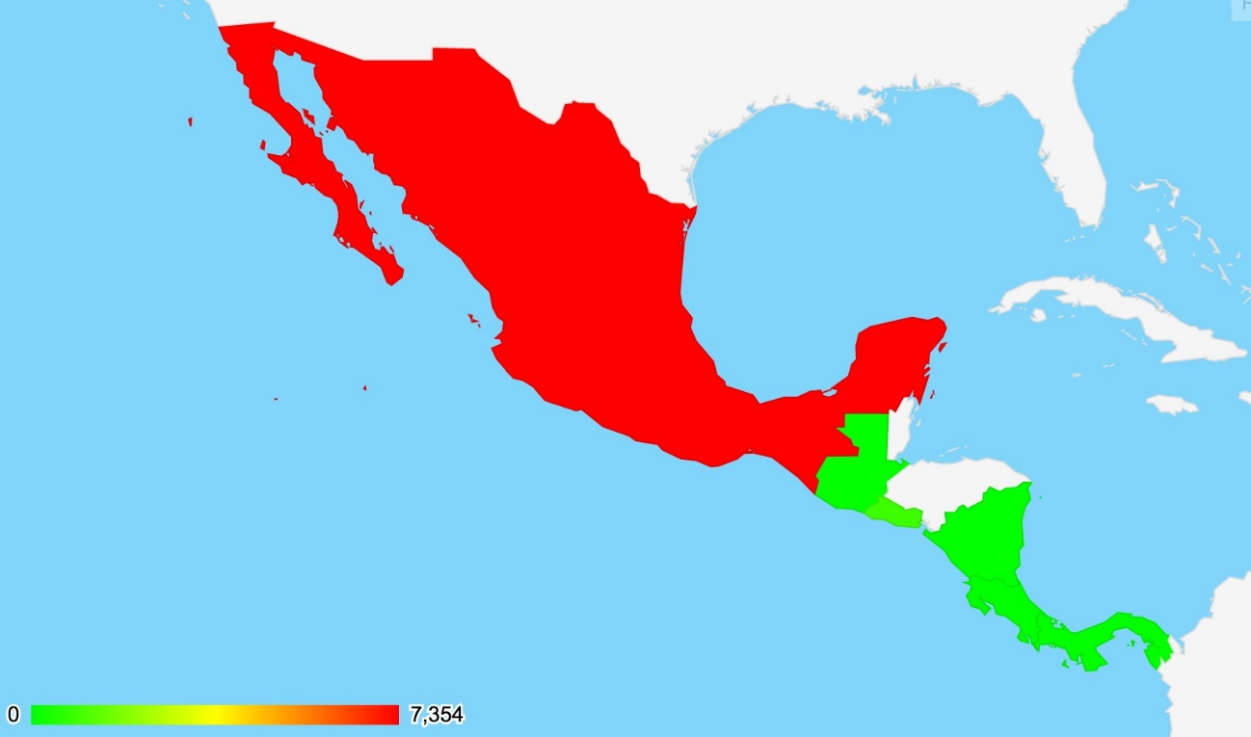

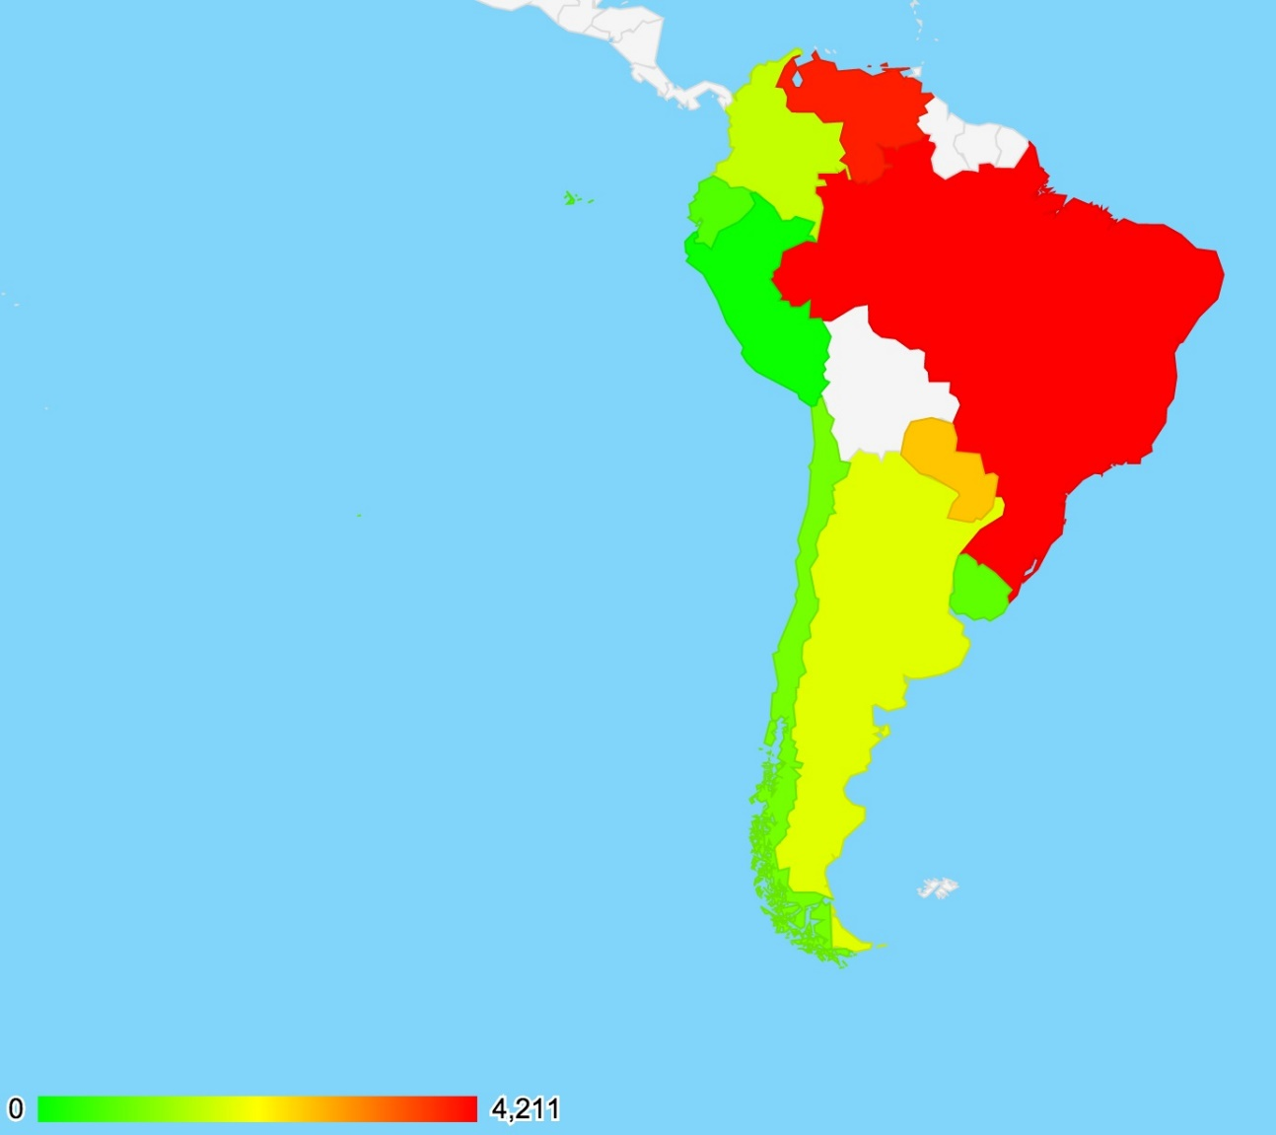

**Climate related protest distribution in South American**

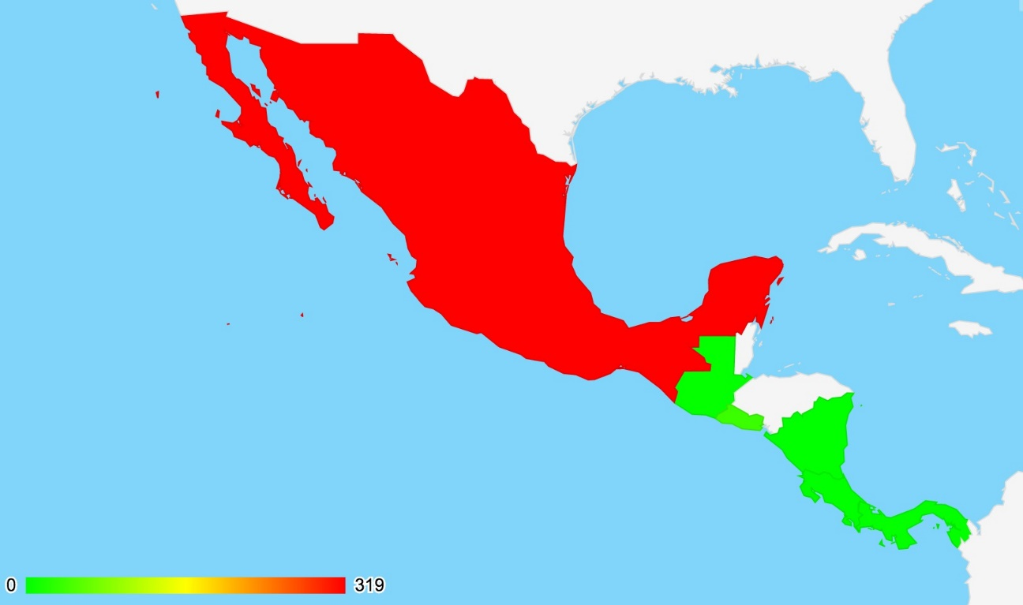

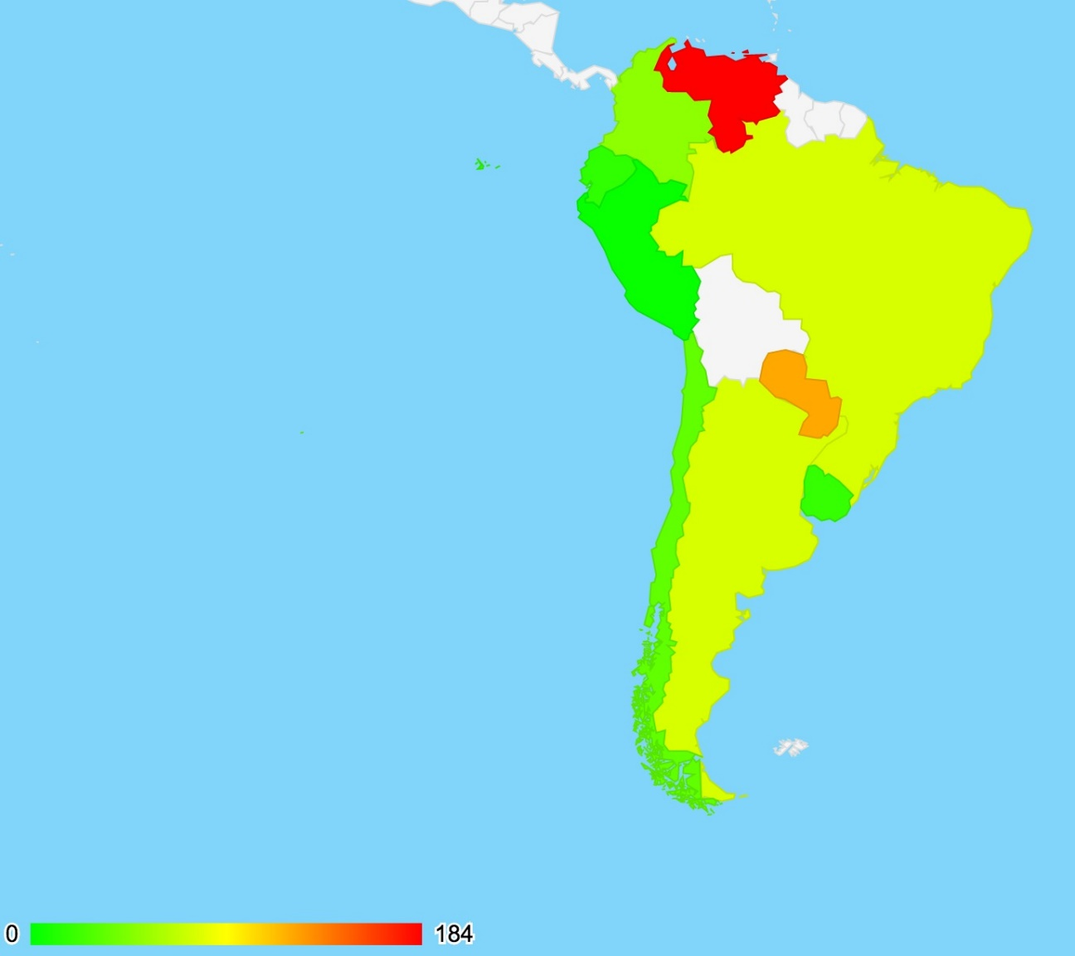

**Climate related protests percentage over GSR**

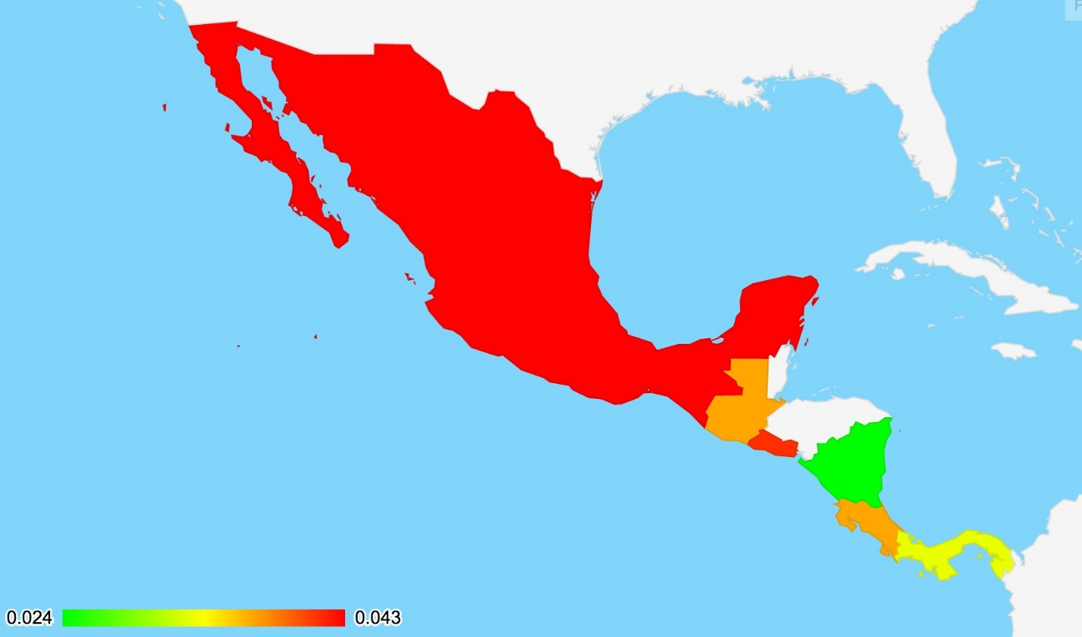

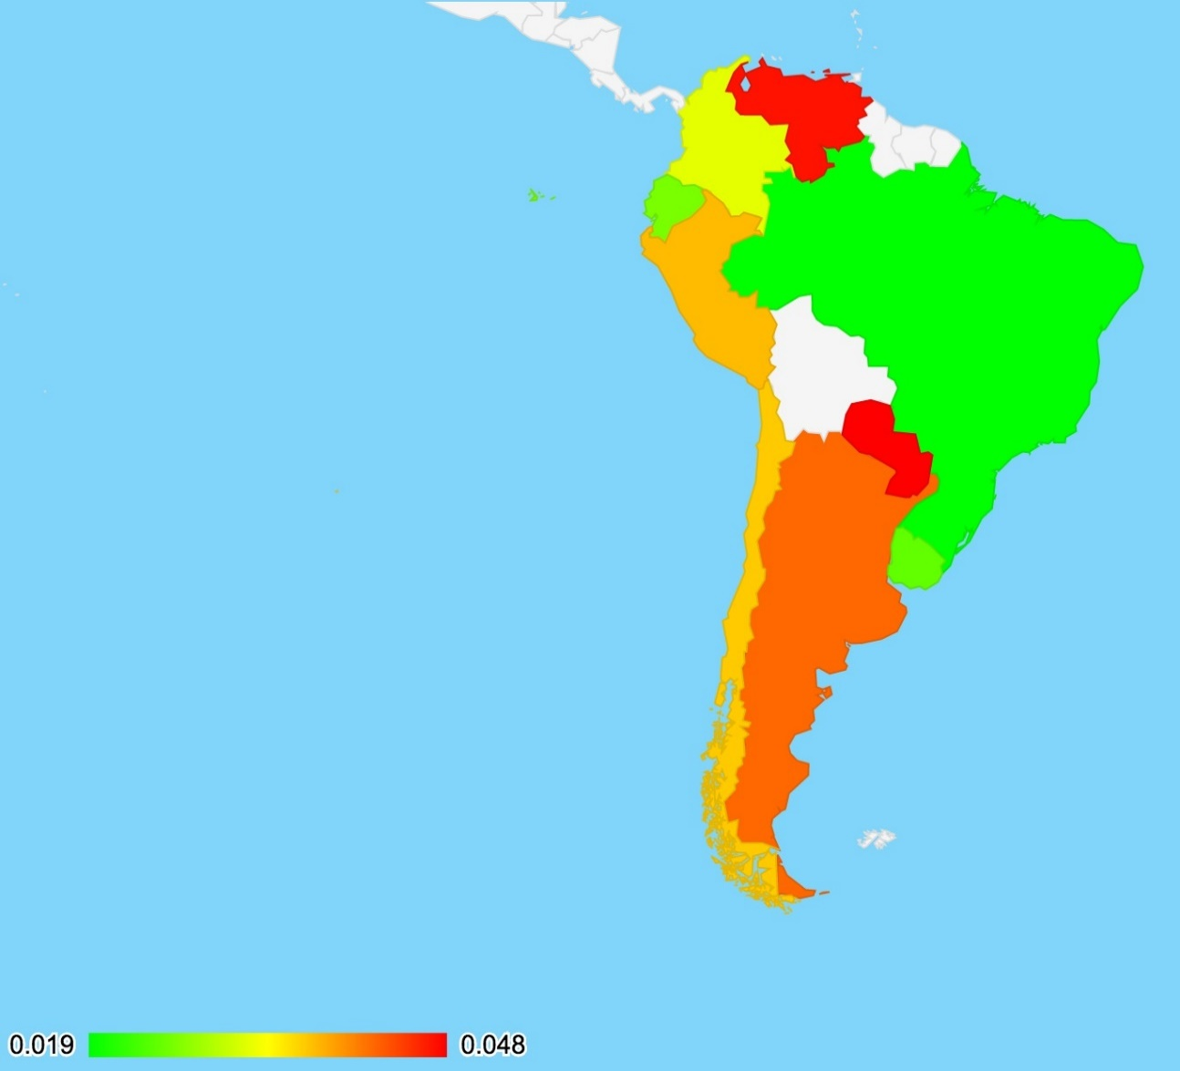

**Figure 1 GSR protest event distributions**

**Figure 2 Climate-related protest events percentage**

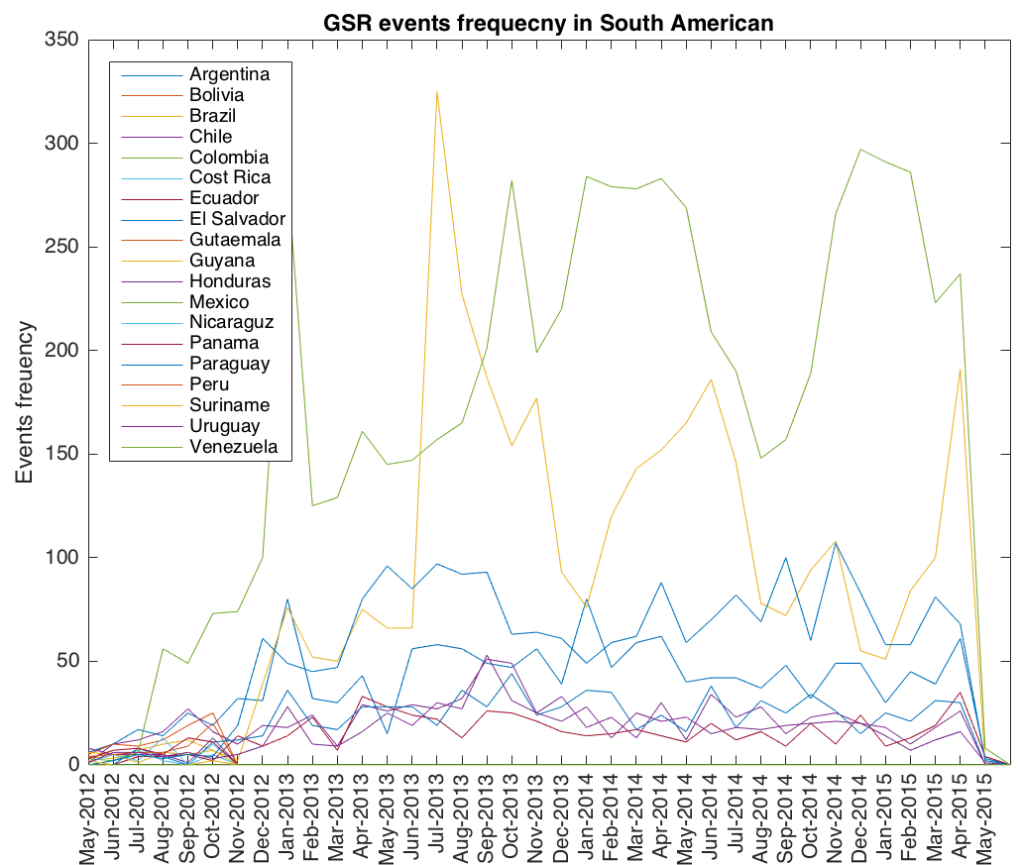

**Figure 3.1 GSR protest events numbers by country/month, from Jan 2011 to Mar 2015**

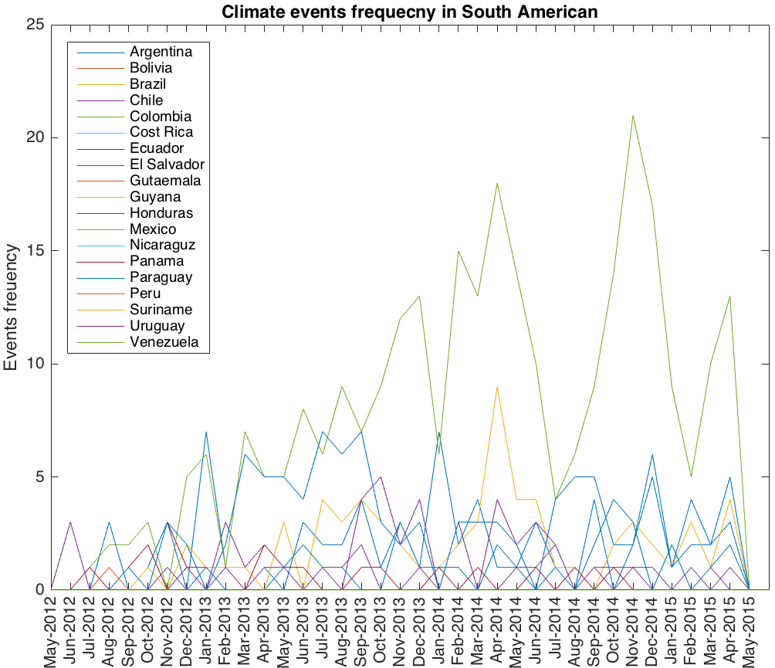

**Figure 3.2 Climate related protest events numbers by country/month, from Jan 2011 to Mar 2015**

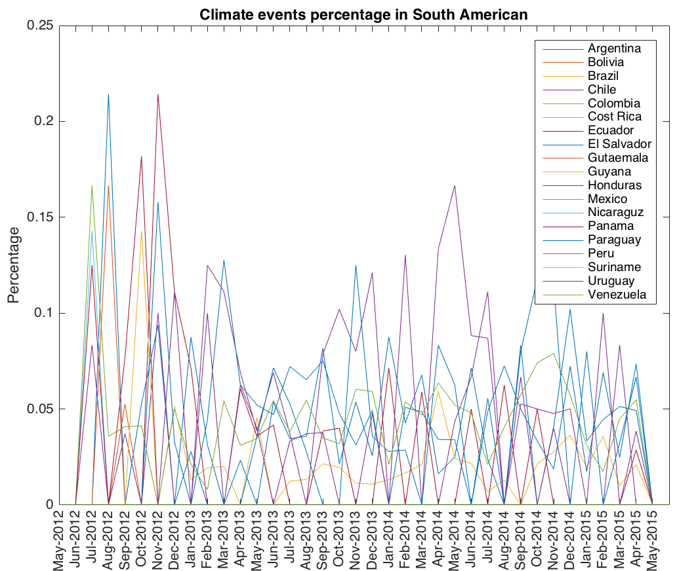

**Figure 3.3 Climate related protest events percentage by country/month, from Jan 2011 to Mar 2015**

**Figure 3.4 Top 10 Climate related protest events percentage by country/month, from Jan 2011 to Mar 2015**

**Climate events – GSR events – Climate related protests percentage by country**

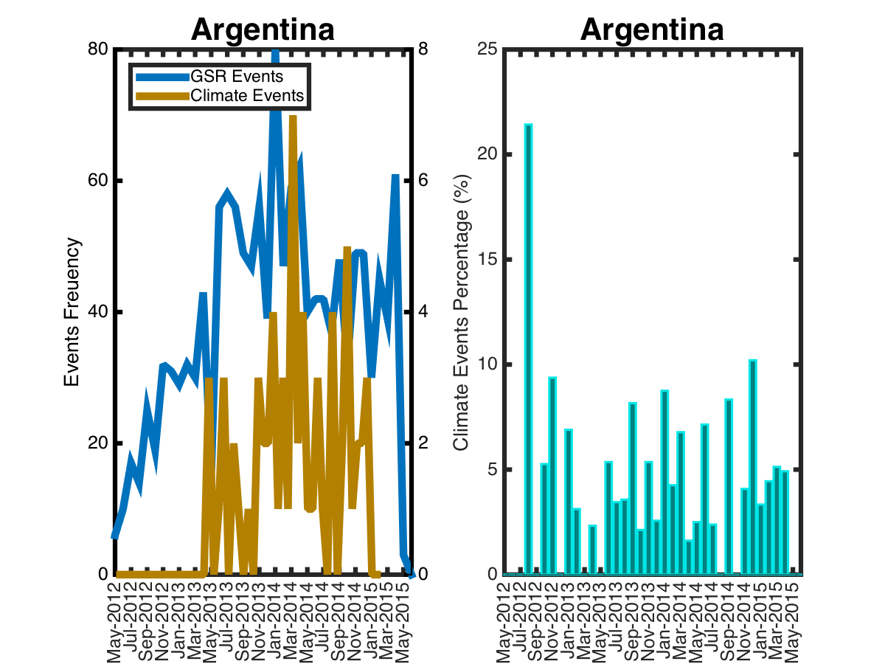

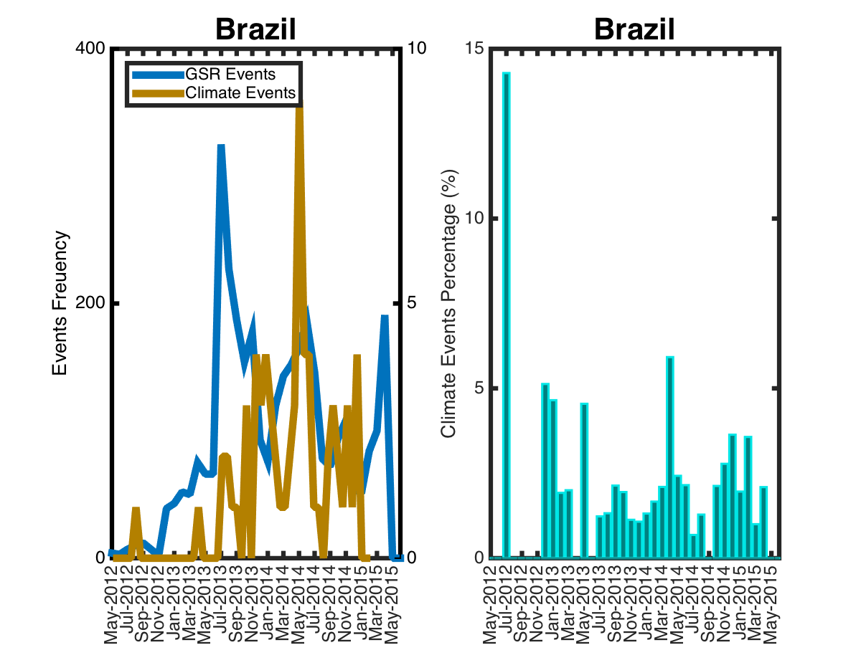

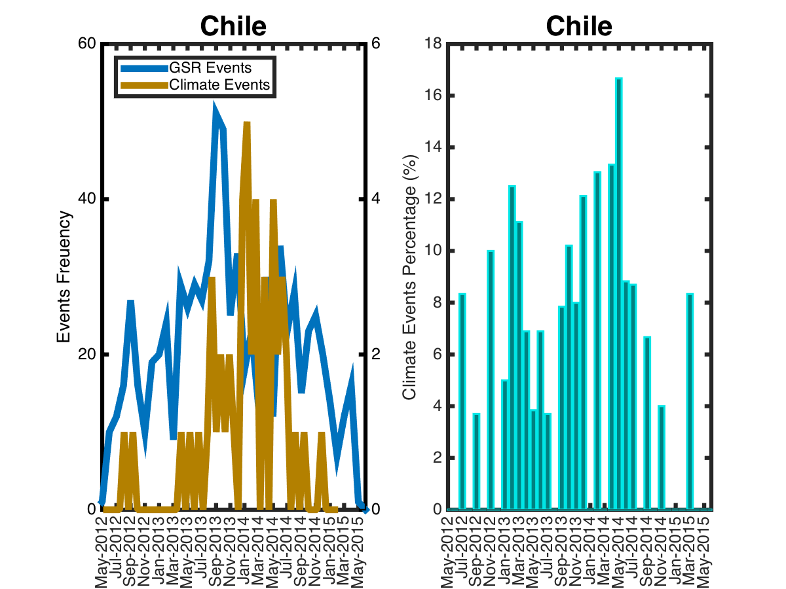

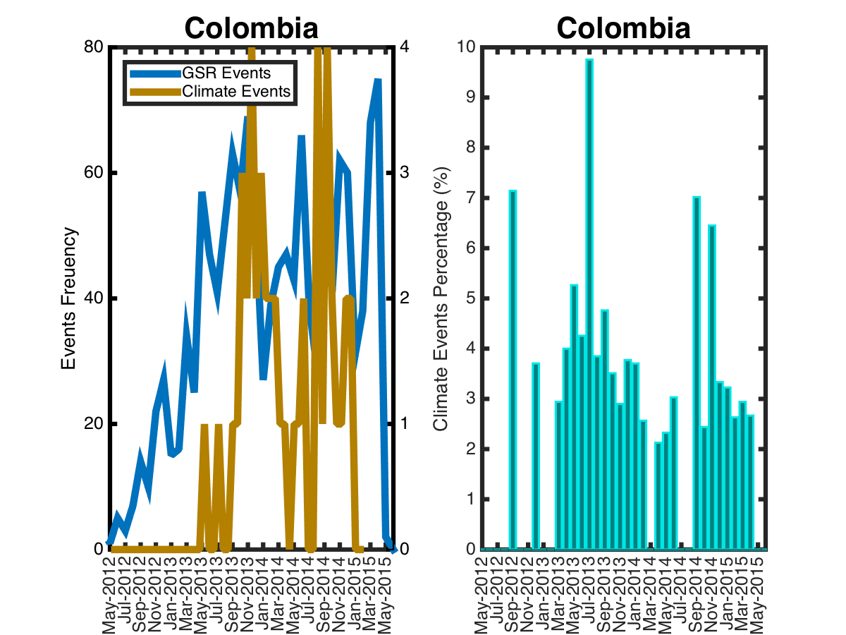

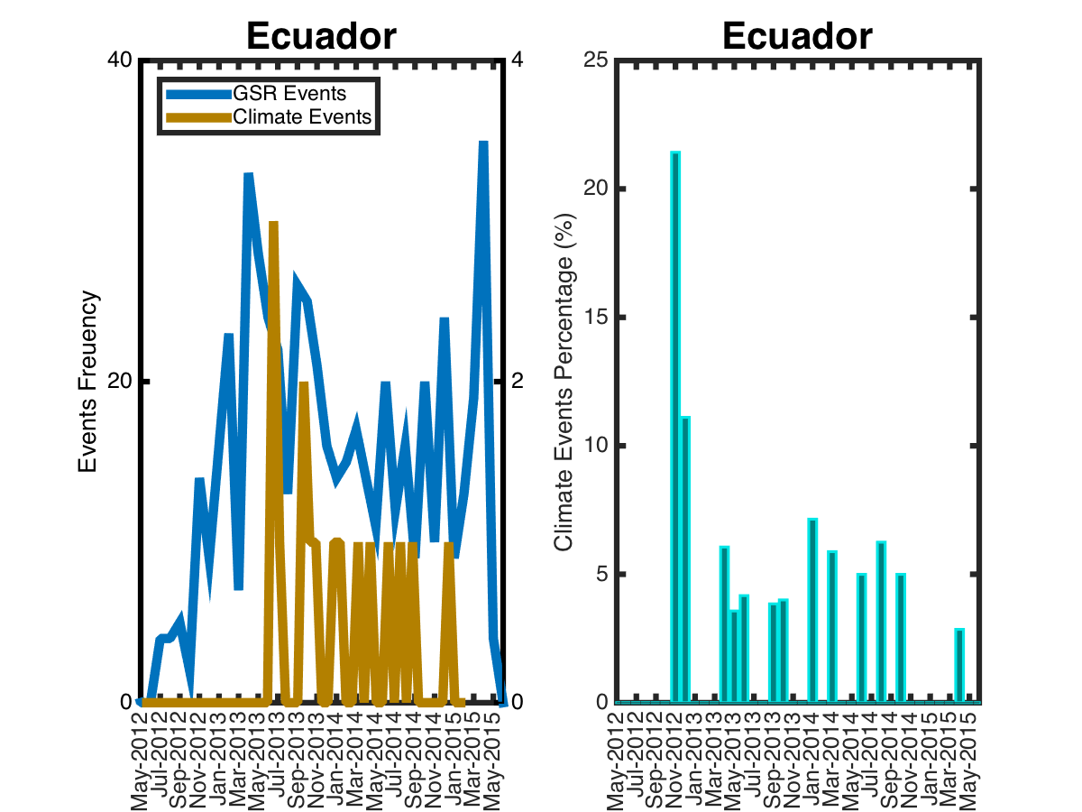

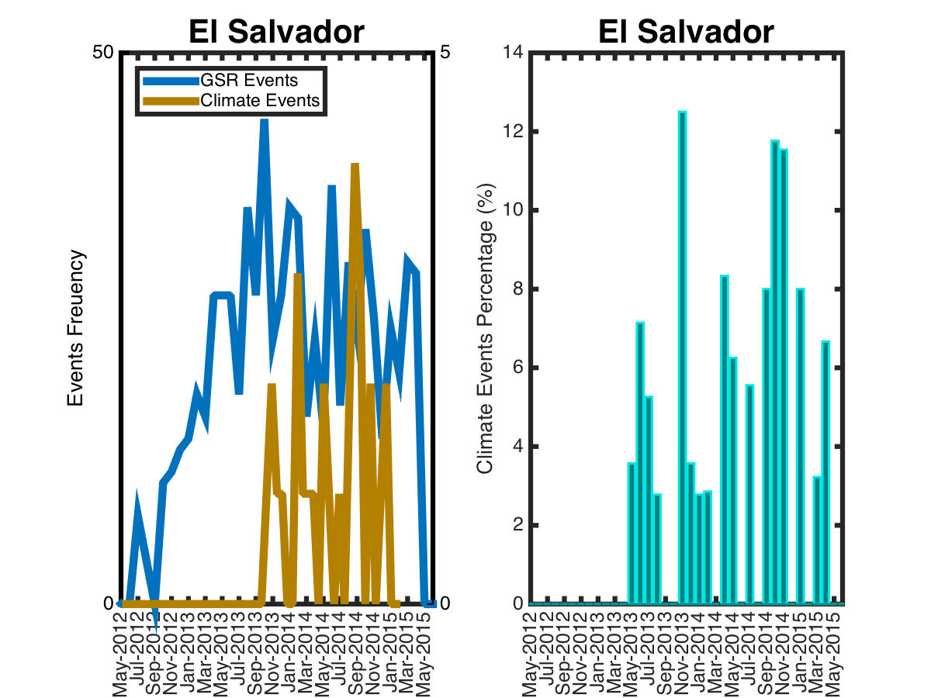

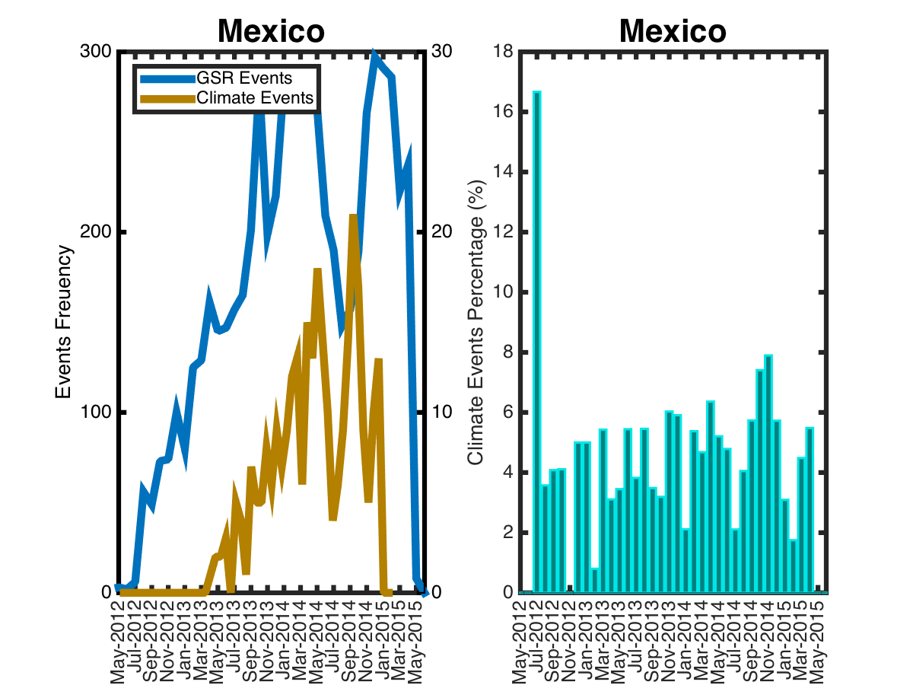

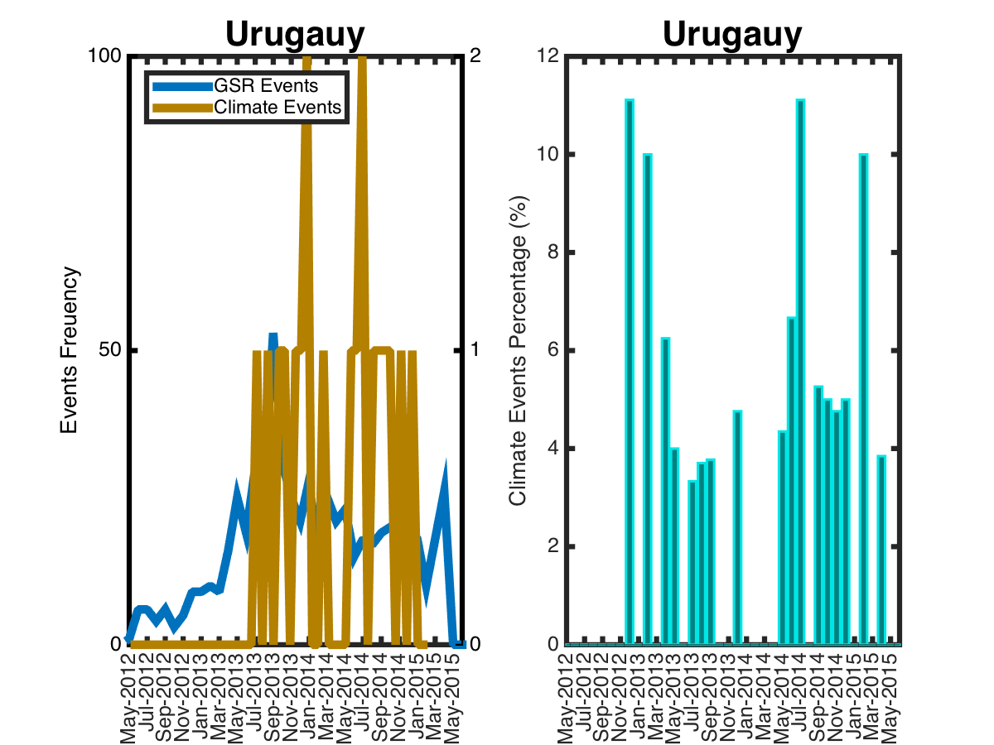

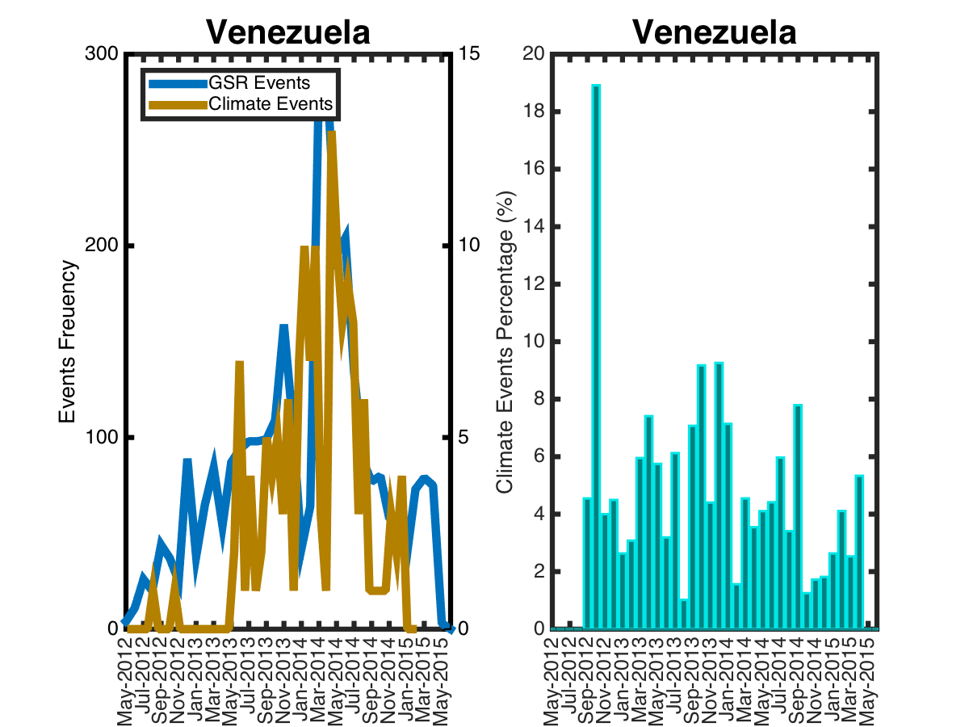

**Climate related protests event Type**

**Figure 4 climate-related events type distributions in South American**

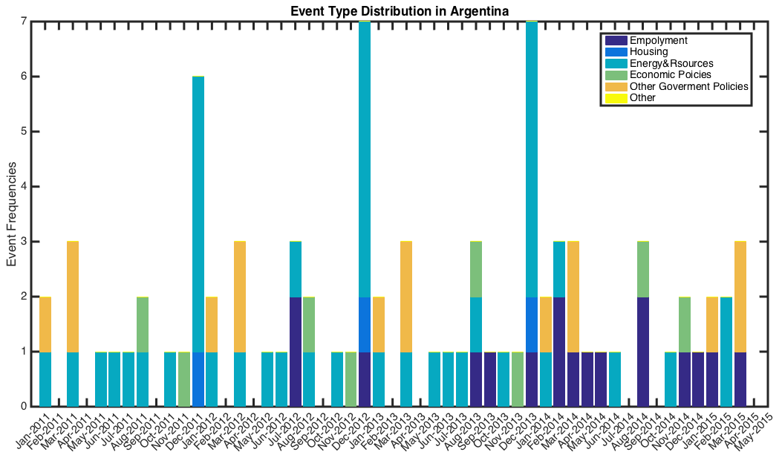

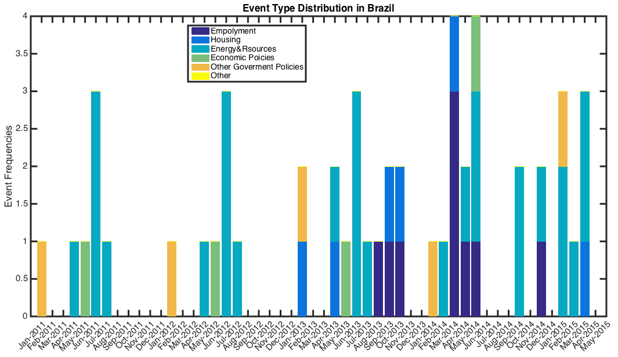

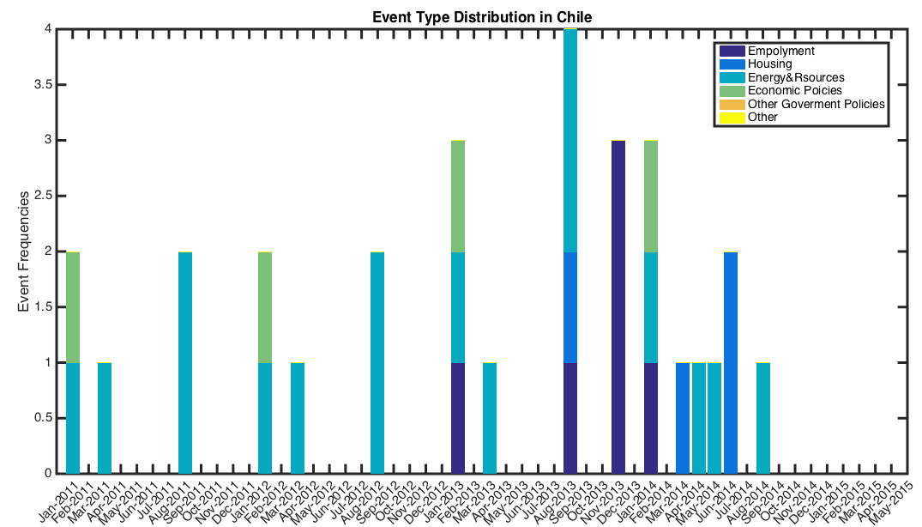

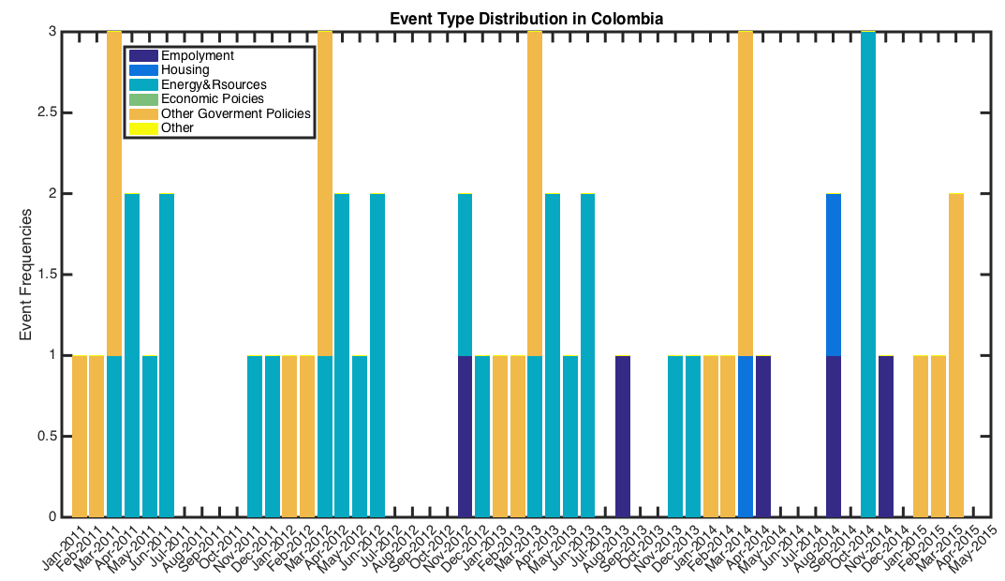

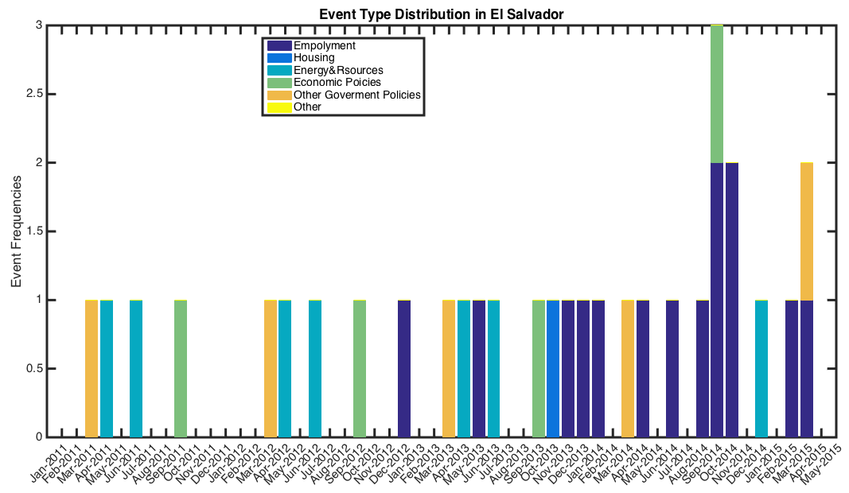

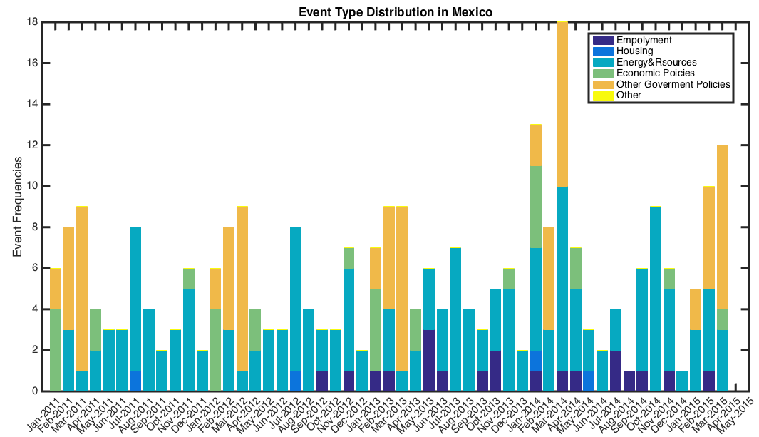

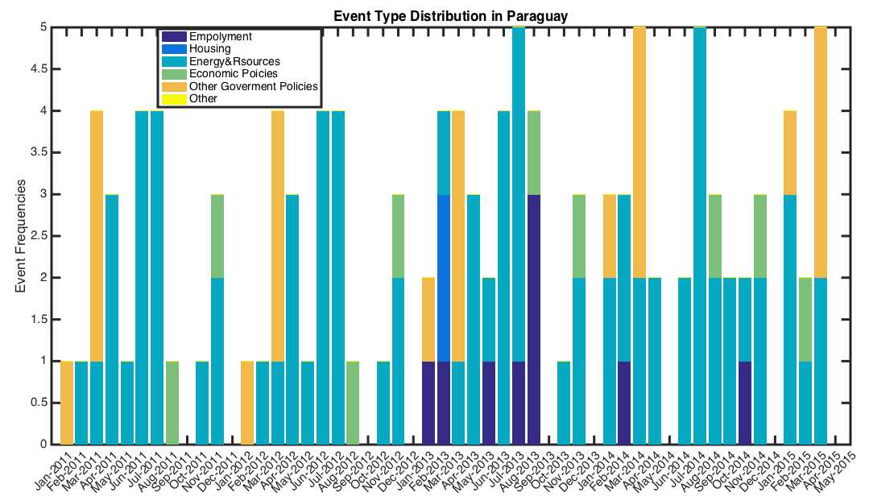

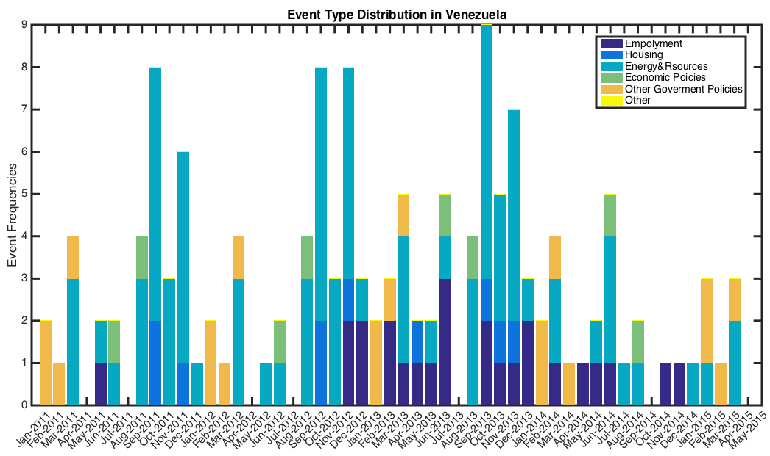

**Climate related protests examples**

Table 1 lists some typical climate-related protest events identified by the KNN algorithms.

**Table 1 typical climate-related protest events**

|  |  |  |  |
| --- | --- | --- | --- |
| No. | Country  & Date | Photos | Climate-related protests description |
| 1 | Brazil  Jan 2015 |  | * The Jacarei river dam is part of São Paulo’s Cantareira system of dams. * A worker from the São Paulo state company that provides water and sewage services inspects cracked ground near Jaguary dam, Braganca Paulista. * Scientists say Brazil’s weather patterns have been disrupted by the loss of Amazon rainforest |
| 2 | Mexico  Sep 2013 |  | * On September 15, 2013, Mexico experienced the most intense rainfall with the onset of Hurricane Manuel. * Within 24 hours, Hurricane Ingrid also struck Mexico’s gulf coast. These two hurricanes left over 150 people dead. |
| 3 | Brazil | crowded classroom | * Students of the Federal University of Pernambuco (UFPE), Recife, protest the heat in classrooms * The discomfort caused by heat took eight thousand workers of the Rio Grande Shipyard to strike in the city of Rio Grande |
| 4 | Paraguay  Sep 2013 |  | * Severe Water Shortage and Lack of Rain for a long time. * Government did not provide any aid or assistance to farmers. * Farmers Protest towards Government on 09/25/2013 asking for assistance |
| 5 | Venezuela  Mar 2013 |  | * Outer Bands impact caused by Hurricane Isaac, Aug 2012. * Government failed to help victims in post-disaster reconstruction. * Flooding victims still live in ruins. General Protest towards Government and Energy on 03/25/2013 for more assistance for victims. |
| 6 | Argentina  Mar 2013 |  | Severe storm struck city and caused Urban Waterlogging.  Government failed to take emergency measures to help civilians.  General Protest towards government on 03/23/2013. General Protest towards government and energy on 03/25/2013 |
| 7 | Chile  Mar 2013 |  | * Event to commemorate tsunami and earthquake of February 27, 2010. * Turned to Violent Riot on 03/14/2013 at Concepción. More than 60 participants have clashed with police and burned several police vehicles. |
| 8 | Chile  Aug 2010 |  | This after this morning, twenty neighbors of said housing complex commune protested with banners to denounce that there are five buildings that are not repaired after the earthquake in February 2010. |
| 9 | Brazil  2012-2013 |  | * Severe water shortage and lack of rain for a long time. Government slow to acknowledge crisis * General protest towards government on 12/14/2012 at Pedra Branca. * Farmers protest towards government on 01/14/2013 at Brazil. |
| 10 | Honduras  Oct 2012 |  | * Storm lasted for several days and caused the flooding * Threatening civilians’ Lives and property * General protest towards government on 10/15/2012 for its indifference and disregard |
| 11 | Chile  Dec 2012 |  | In the same commune, but in the city of Montenegro, they attempted transit cuts and protests occurred last night on Route 5 North in claim odors emanating from the plant Porkland pigs. |
| 12 | Brazil  Feb 2014 |  | Guaratiba residents in the West Zone of Rio, make a demonstration in the early hours of Monday, the Road Magar due to lack of light reaching the region. |
| 13 | Chile  Jan 2014 |  | A group of residents protested this Tuesday against a project to destroy an area devoted to green areas in the Conchali. |
| 14 | Brazil  Jun 2012 | Traditional fishing in the Xingu. Photo Credit: Christian Poirier  Sacrificing the Amazon and its Peoples for Dirty Energy | About 300 indigenous people and environmentalists protested against the construction of Belo Monte hydroelectric dam in Altamira, PA. The demonstration occurred about 50 kilometers from the county seat, in the area known as a cofferdam, a kind of earth dam built on the Xingu River Consortium Builder Belo Monte. |
| 15 | Argentina  Jan 2013 | Residents of the Flores neighbourhood in central Buenos Aires protesting the outages during Argentina’s worst heat wave in 100 years. Credit: Fabiana Frayssinet/IPS | Tired of repeated blackouts, the residents of Villa Crespo cut yesterday afternoon Scalabrini Ortiz street, at the height of Murillo. They claim that since November last year have suffered interruptions in electrical service. |

### Storytelling Algorithm

The story telling algorithm we employed is based on weighted scores of similarities across news articles for three sets of features: textual features (related to keywords), spatial features (such as locations and geographical coordinates), and actors (such as person(s), and organizations mentioned in the articles) [1].

The chaining methodology is developed with the goal of identifying all documents related to a climate change story and to keep track of the news story as new documents arrive. Documents belonging to such a chain cover the same event and are ordered by time. The algorithm operates in an incremental fashion wherein every new input article is analyzed as it arrives and is appended to already existing chain(s). This analysis involves a two-step process. In the first step, we compare an incoming article Di to articles from the last n1 days to identify the most similar articles and then designate candidate chains to which the current article can be attached to. If no similar articles are found, then a new chain is created with this article as a seed.

Further, to assess if two documents are referring to the same underlying context, we calculate their similarity scores with respect to three features:

- textual features, denoted by T (Di),

- spatial features, denoted by L(Di), and

- actors, denoted by A(Di).

The textual features are represented by the TF-IDF vector of the tokens present in the document. The spatial features are the set of locations mentioned within the text of an article. Similarly, the actors feature vector (A(Di)) represents the set of actors (persons, organizations as detected by NER) mentioned in an article. The total weighted similarity measure between two documents, Di and Dj , is then defined as follows:

sim(Di;Dj) , _f(T (Di); T (Dj)) + _f(L(Di);L(Dj)) + _f(A(Di);A(Dj));

The storytelling algorithm is employed to track the evolvement process of a climate event, from its beginning to its ending, and finally develop into a civil unrest event. To avoid confusion, we build story chains country by country. We collect each country’s RSS news from its top leading news agencies, for instance, Brazil news comes from Brazil– O Globo, Estadao, and Jornal do Brasil. In addition to this data, we also have access to a human curated list of civil unrest events that happened during this period. This list, called the Gold Standard Report (GSR) described in [5], contains news reports for each event from the three major news sources. For each country’s document stream, we employ storytelling algorithm.

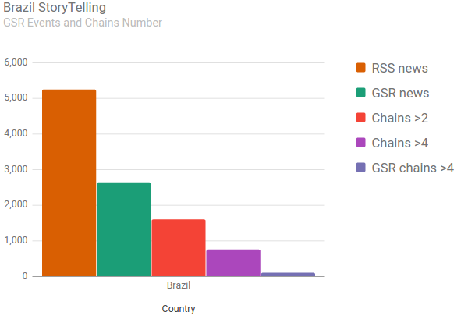

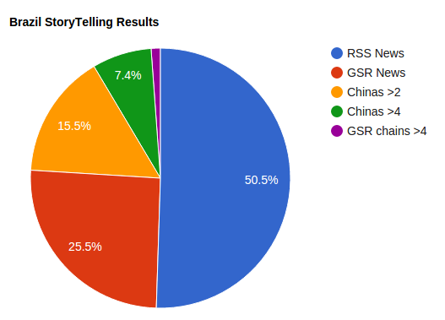

The following shows some story chains for climate related protest events.

## Chain one: Mexico hurricane protests, Dec 2013

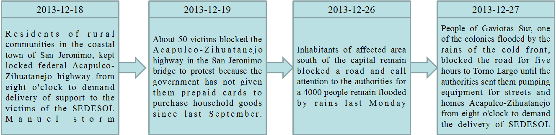

**Figure 5 Mexico Hurricane protest story chain**

## Chain two: Brazil heat wave protests, Feb 2014

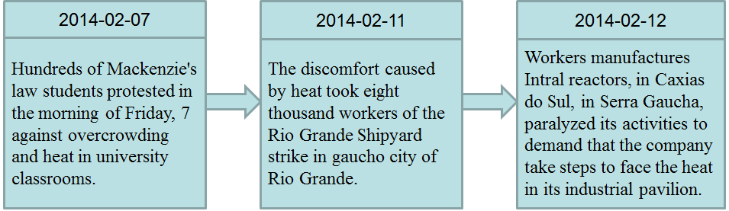

**Figure 6 Brazil heat protest story chain**

## Chain three: Chile construction protests, 2013

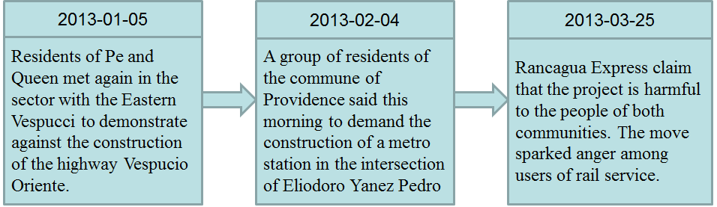

**Figure 7 Chile construction protest story chain**

### 

### Dynamic Query Expansion

As Twitter data is quite different from articles or news, we apply Dynamic Query Expansion (DQE) [2] in our work which is specific design for twitter analysis. DQE algorithm utilizes heterogeneous features (e.g., containment, authorship, and replying etc.) extracted from Twitter data to expand seed query.

### DQE Algorithm

In order to describe DQE processing, we need to make several important definitions:

Definition 1 (Twitter Heterogeneous Information Network) A Twitter heterogeneous information network is defined as an undirected graph $G=(V,ε,W,S)$, where $V=T∪F$. $T$ refers to a set of tweet nodes, and $F=F_{1}∪... ∪F_{M}$ refers to other M types (e.g., term, user and hashtag) of nodes, called feature nodes. $ε⊆V×V$ represents the set of edges, which are all undirected. We denotes the existence of an edge between two nodes $v_{i},v_{j}∈V$ by $v_{i}↔v_{j}$. $W$ denote the set of weights of nodes and edges. $S=\{l(v)|v∈T\}$ refers to a set of geographic locations of tweet nodes, where $l(v)∈R^{2}$ represents a tuple consisting of the latitude and longitude of tweet node $v$. When $M=0$, $G$ reduces to a Twitter homogeneous information network $G_{0}$.

In addition to tweet nodes, we consider several other types of nodes, including “term”, “hashtag”, “hyperlink”, and “user”, all of which are generally called feature nodes. The relationships between these types of nodes are denoted by the set of undirected edges $ε$, including authorship between user nodes and tweet nodes, containment between tweet nodes and term nodes, and replying between tweet nodes.

Definition 2 (Seed Query) A seed query is defined as an initial set of semantically coherent feature nodes that characterize the concept of the targeted domain. A seed query is denoted as $Q_{0}={\{(v_{i},{w(v_{i})}^{(0)})\}}_{i=1}^{N}$, where the feature node $v_{i}$ is a seed query term whose weight ${w(v_{i})}^{(0)}∈R^{+}$ reflects its relevance to the targeted domain. An expanded query is an extended set of weighted feature nodes that represent the semantic contexts of spatial events. Similar to seet query, an expanded query is denoted as $Q={\{(v_{i},w(v_{i}))\}}_{i=1}^{N^{'}}$, where $v_{i}$ is called an expanded query term.

All the seed query terms have corresponding edges denoting their semantic relevance. For example, given a seed query of the domain “civil unrest”: {(“protest”, 1), (“march”, 1), (“strike”, 1), (“unrest”, 1)}, an expanded query can be: {(“#megamarcha”, 0.1), (“#YoSoy132”, 0.3), (“zocal”, 0.1), (“march”, 0.2), (“imposición”, 0.1)}, which matches the news description: “A mega march against the imposition of PRI: YoSoy132 protesters arrived at El Zocalo.”

Denote $C=\{C_{1},C_{2},...,C_{P}\}$ as a collection of time-indexed Twitter data, where $C_{p}∈C$ represents the subcollection of tweets posted between timestamps $t_{p-1}$ and $t_{p}$. To achieve targeted domain spatial event detection, one needs to concentrate on domain-related tweets and detect the spatial burst signals based on them. The major tasks of the problem are defined as follows:

Task 1: Dynamic Query Expansion: Given $C_{p}$ and a seed query $Q_{0}$ of a targeted domain, expanded query generation is to generate the expanded query $Q_{p}$ by expanding $Q_{0}$ through the Twitter heterogeneous information network $G$.

Task 2: Events Clustering: Given a targeted-domain related tweets subset extracted based on $Q_{p}$ from $C_{p}$,events clustering is to automatically identify a set of events, each of which is specified by geolocation, time and related tweet nodes.

DQE algorithm can be summarized as follows:

1. Predefine a keywords list. In our project, we predefine a weather and climate disaster keywords list and a civil unrest keywords list based on WordNet and Wikipedia. To be specific, civil unrest keywords list mainly includes protest, march, manifest, strike, unrest, violence etc. And weather and climate disaster keywords list contain various kinds of keywords about disasters, including cyclone, hurricane, tornado, twister, typhoon, storm, hailstorm, thunderstorm, tempest, flood, deluge, drought, aridity, shortage, heat, torridity and so on. Moreover, as the official language of Latin American countries is Spanish and Portuguese, all keywords lists include corresponding keywords among English, Spanish and Portuguese.
2. Update keywords list based on DQE processing, and then find tweets including related keywords.
3. Extract expanded keywords from tweets in Step 2.
4. Repeat Step 2 & 3 until the keywords list and related tweets list relatively convergence.
5. Get final keywords list and corresponding tweets collection.

Details processing of DQE are illustrated in case study section.

#### DQE running results snapshot

The two figures of DQE Processing are based on DQE result on Sep. 12th, 2013. There are 116 events on that day and each of them is represented as a spot in the graph. The size of the spot is measured by related tweets from several to thousands. And the location of spots is based on the result of geolocation clustering on city level.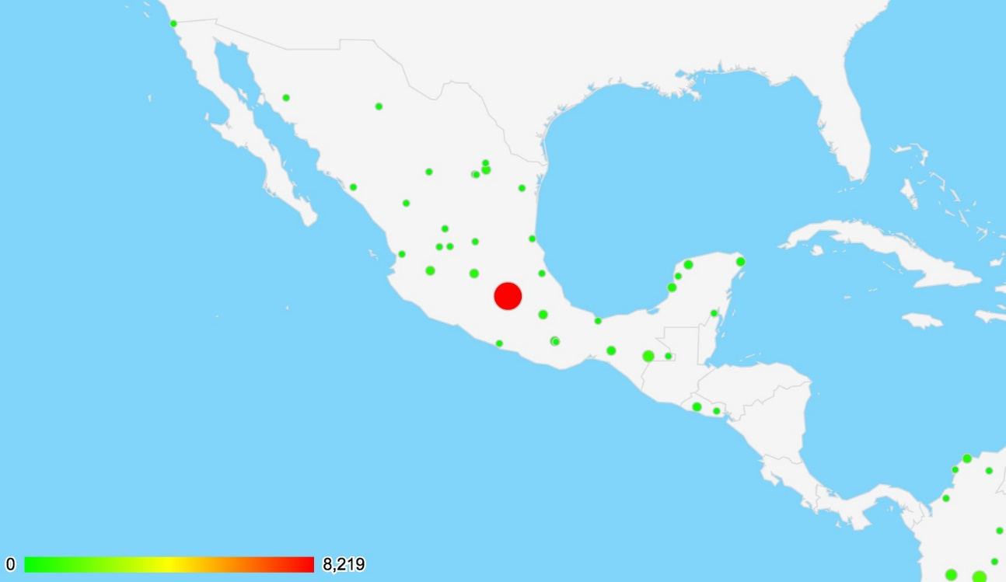

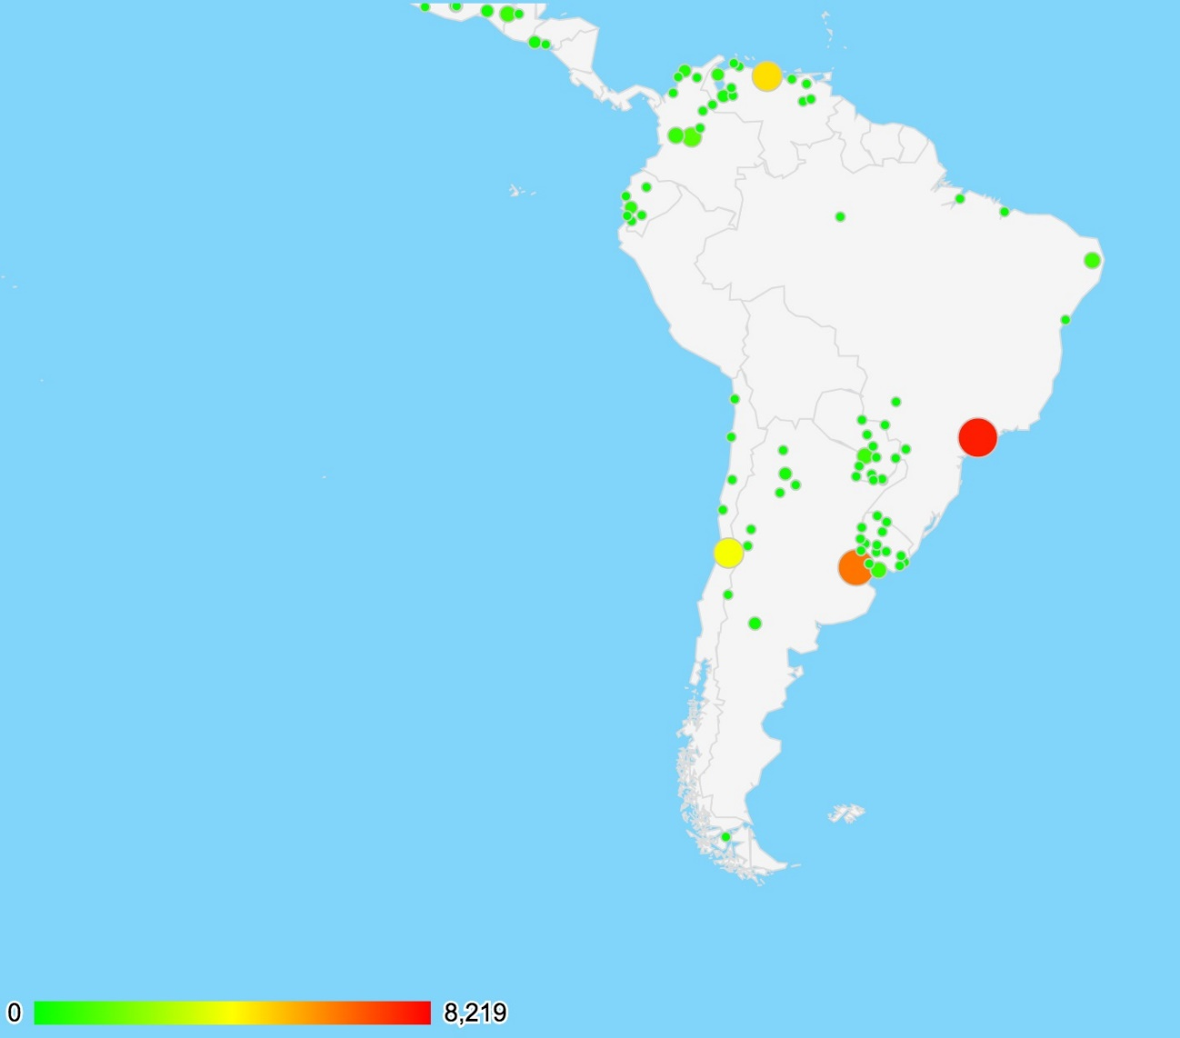

**There was 116 events in South American on Sep 12, 2013. Each of them is represented as a spot. Size of the spot signifies related tweets number.**

#### Events Clustering

After DQE processing, we have keywords list and corresponding tweets collection. In tweets collection, there is not only the content of the tweets, but also many other features including user profile, publish timestamp, geolocation (different granularity) etc. All these features are important to events clustering as well as the content of tweets collection. Therefore, as all these features and content of tweets are of great importance in events clustering, appropriate coefficient should be assigned in a distance function for each term, which is a method to measure the similarity among different tweets. With appropriate distance function, tweets collection can be separated into different partitions, and each partition includes similar tweets which are related to specific event. We need some further analysis and experiment to determine what kind of distance function have better effectiveness. Events Clustering processing can be summarized as follows:

1. Input tweets collection and related features.
2. Clustering tweets into different partitions based on similarity among tweets using distance function, taking tweets content, geolocation and other features into consideration.
3. Each partition includes similar tweets stand for a specific event.
4. Filter unrelated and false positive events.
5. Merge related events if needed.

Figure 7 illustrates the processing of Events Clustering, which is also from Mexico Hurricane Ingrid and Manuel Event in Sep. 2013. Each of the graph in Figure 7 is an event happened around Mexico Hurricane. The two graphs on the left side are related to Mexico Hurricane Ingrid and Manuel, while the two graphs on the right side are related to CNTE (Teacher Union in Mexico) protests. On the top left side, Figure 7a illustrate the two Hurricane Ingrid and Manuel, while Figure 7c, on the bottom left side, is also related to Hurricane Ingrid and Manuel, but mainly focus on the flood at costal city Acapulco after the Hurricane Manuel landed for the first time. On the top right side, Figure 7b is about CNTE protest in Zócalo which is the common name of the main square in central Mexico City. And Figure 7d, on the bottom left side, mainly focus on the event that the police started to clear striker of CNTE.

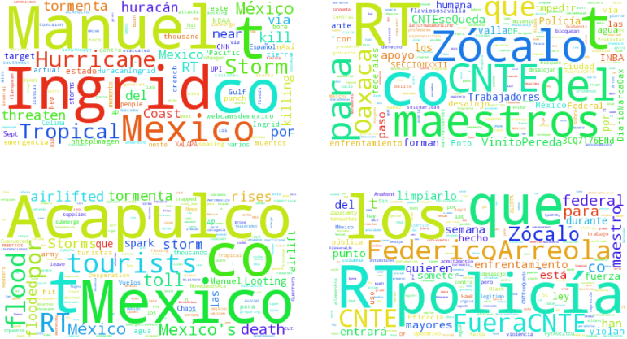

**Figure8 Events Clustering Processing**

Events Clustering is used to separate events happened at same place or at same time, or the separate different events happened simultaneously on local and entire country. By measure the distance among tweets based on similarity, tweets collection can be clustered into subsets in which tweets are exactly related and similar. Without events clustering, different events will be mixed. In Figure 8, Mexico Hurricane were mixed with severe drought happen in Culiacán, which is an important and big city in northwestern Mexico.

## Events Distribution

The pie chart illustrate the distribution of events on Sep 13th, 2013. The two column charts are the distribution of events from Sep. 13th, 2013 to Sep. 19th 2013 and from Sep. 15th, 2013 to Oct. 15th, 2013, respectively. From the figure, we can see that the number and distribution of events for each country remains relatively constant, unless triggered by some huge or important thing. And also the number of events is not necessarily related to the area of territory or population, for Mexico have much more events than Brazil and Argentina.

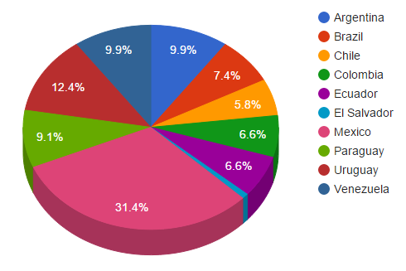

**Events distribution of DQE on Sep 13th, 2013**

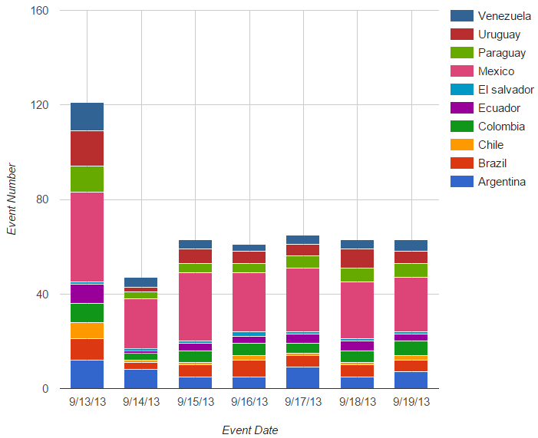

**Events distribution of DQE from Sep. 13th to Sep. 19th 2013.**

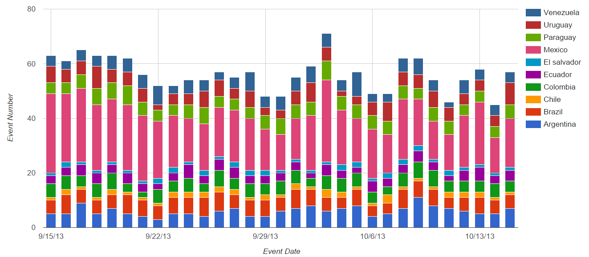

**Events distribution of DQE from Sep 15th, to Oct 15, 2013**

## Case Study: Overview

In order to illustrate the abilities and effectiveness of our method, several case study were elaborated in this section. These case study includes all kinds of weather and climate events, including hurricane, storm, flood, drought, heatwave etc. As a matter of fact, we have also tried lots of other keywords to capture different kinds of events. The results show that our method can capture all kinds of weather and climate events as well as corresponding civil unrest events, and our method can also be expanded with appropriate keywords list so as to capture other kinds of natural disaster events, such as outbreak of volcano, earthquake etc. These case study are elaborated as follow:

## Case Study 1: Mexico Hurricane, Sep. 2013

We have already made a case study of Mexico Hurricane happened in Sep. 2013. Before we go to the detail of the case study, we first illustrate the processing of DQE algorithm.

In Sep. 2013, Mexico suffered from the two Hurricane Ingrid and Manuel. On September 15, 2013, Mexico experienced the most intense rainfall in the country’s history with the onset of Hurricane Manuel that battered the northwest. Within 24 hours, Hurricane Ingrid also struck Mexico’s gulf coast. Then Hurricane Manuel make its second landfall. These two hurricanes left over 150 people dead and caused about six billion dollars in damage. After the hurricane, related protests and other civil unrest events break out dozens of time, and lasts for more than 2 years because the government’s response had been desperately inadequate.

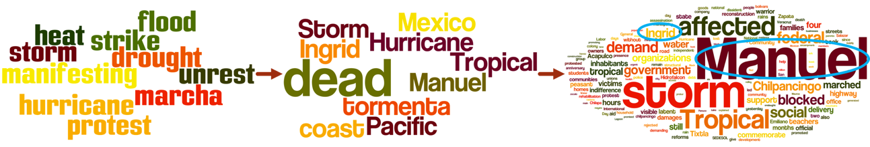

**Figure 9 DQE Algorithm Processing**

Figure 9 illustrates that keywords list is update after each iteration, after several iterations the keywords list and related tweets become relatively convergence. On the top left side, Figure 8a includes seed keywords which are from our keywords lists. Then, Figure 8b, which is on the top right side, illustrates the expanded keywords after the first iteration, in which the name of the two Hurricanes Manuel and Ingird are shown in the graph. On the bottom side, Figure 1c is the final result after several iterations, which includes not only keywords but all words in related tweets collection.

As Figure 8c shows the result of DQE processing, we can know what people are talking about on Twitter at that time. We see strong signal of the two Hurricanes’ name which is Ingrid and Manuel. And the signal of storm and tropical is also strong. Why these word are obvious in Hurricane event? Actually, it is reasonable that Hurricane is a kind of tropical cyclone which is a rapidly rotating storm system. In simple words, hurricane can be considered as a strong storm or tropical cyclone.

Let us focus on the detail of Mexico Hurricane. The hurricane Ingrid and Manuel hit Mexico three time in four days and caused at least 150 deaths. The timeline of this event is shown as below:

* **Sep. 12th:** A broad disturbance at Gulf of Mexico (Ingrid).
* **Sep. 13th:** Tropical Storm form in eastern Pacific (Manuel).
* **Sep. 14th:** Hurricane Ingrid and Manuel form.
* **Sep. 15th:** Hurricane Manuel first landfall, and caused at least 23 deaths.
* **Sep. 16th:** Hurricane Ingrid landfall, and caused more than 80 deaths. Mexico government declared a national emergency.
* **Sep. 17th:** Hurricane Ingrid dissipated.
* **Sep. 18th:** Hurricane Manuel second landfall.
* **Sep. 20th:** Hurricane Manuel dissipated.

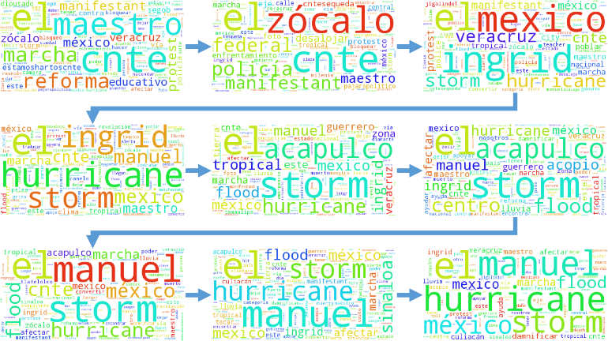

**Figure 10 Word Cloud of related tweets of Mexico Hurricane Ingrid and Manuel from Sep. 12th to Sep. 20th**

As we can see in Figure 10, the case study of Mexico Hurricane is still naive right now. Stop words and low frequency words have not been discarded yet. However, we can see that before hurricane happen it's almost impossible to find hurricane related tweets because no people talks about it, while there are very strong signals of hurricane and storm, even the hurricane just form on Sep 14th (Top of Right Side). And Figure 9 also reflects the pattern of hurricane in some way. In the middle row, the signal of Manuel is getting weak by the time. And the signal of Manuel suddenly gets very strong on Sep 18th (Bottom of Left Side), because hurricane Manuel was landed for the second time on Sep 18th.

Figure 10 illustrates the civil unrest events after the Hurricane Ingrid and Manuel. On the top left side, Figure 10a illustrate protest happened in Acapulco which is a costal city of Mexico which were seriously damaged by the two Hurricane. Figure 10c, on the bottom left side, is protest asking for more help from Mexico government because of the cold winter in 2013. Other graphs shown in Figure 10b and 10d on the right side are also civil unrest events asking for more help from Mexico government. Actually, dozens of civil unrest events broke out in the next two years, and the latest protest broke out on Jun. 2015.

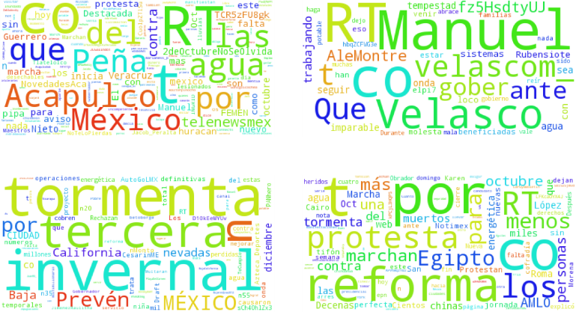

**Figure 11 Word Cloud of Civil Unrest Events after Mexico Hurricane Ingrid and Manuel in Sep. 2013**

## Case Study 2: Extreme Weather, Culiacán, Mexico, Sep. 2013

* Culiacán, which is an important and big city in northwestern Mexico suffered from severe Drought for quite long time, was also affected by storm and flood on Sep. 18th, 2013.
* Storm hit the city Zihuatanejo, which is the fourth-largest city in the Mexican state of Guerrero
* Acapulco de Juárez, commonly called Acapulco, was inundated by flood caused by Hurricane. Acapulco is a city, municipality and major seaport in the state of Guerrero on the Pacific coast of Mexico.
* Flood caused by surrounding influence of the Hurricane affects the city San Luis Río Colorado, which is a city and its surrounding municipality lying in the northwestern corner of the state of Sonora, Mexico, on Sep 18, 2013.

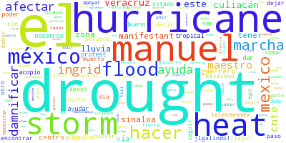

**Figure 12 Mixed Events without Events Clustering**

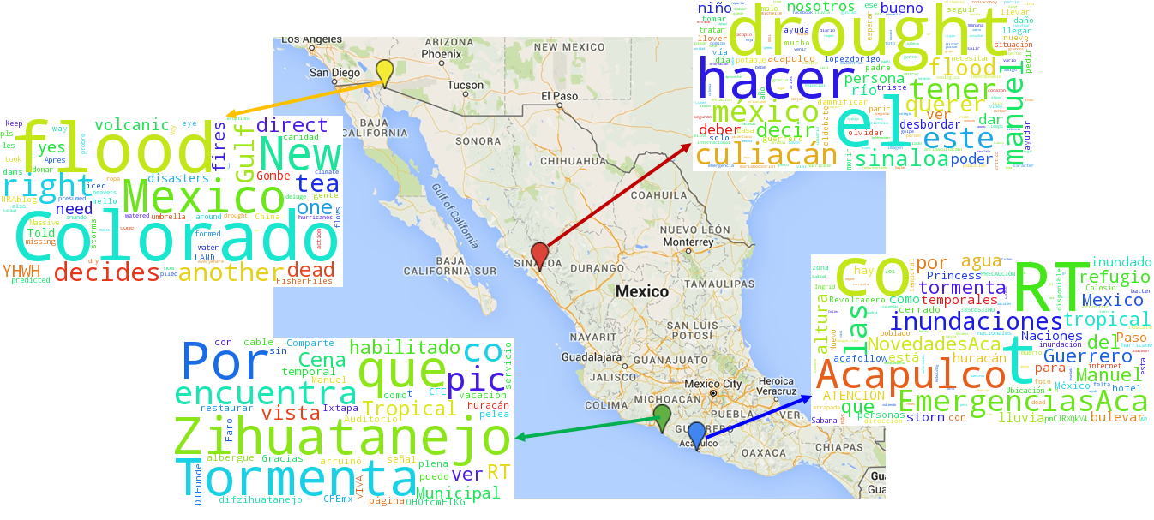

**Figure 13 Mexico Climate Events using Events Clustering**

## Case Study 3: Brazil Drought, May 2012

Severe drought happened in Brazil at 2012 also got strong signal in DQE processing.As our Twitter data started on May 1st, 2012, strong signal of drought in Brazil continued since May 1st, 2012 for at least 5 months. This drought is also known as the worst drought in Brazil for the past 50 years.

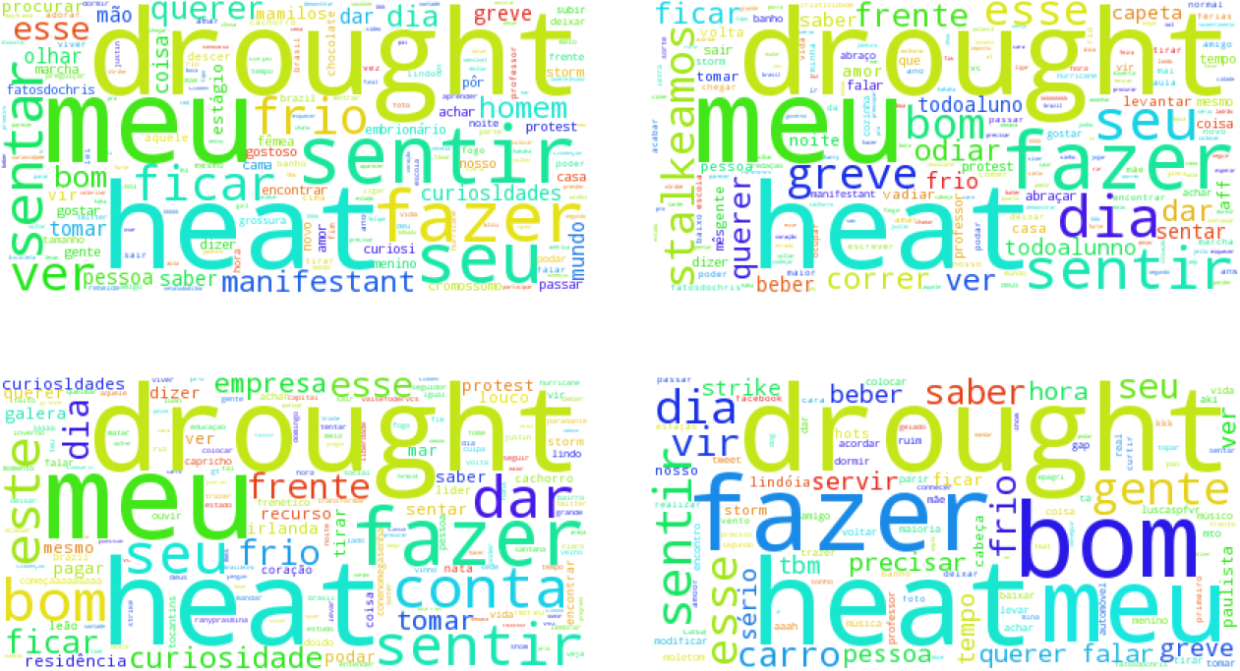

**Figure 14 Word Cloud of Brazil Drought**

As we can see in Figure 14, Figure 14a, 14b, 14c, and 14d stand for the word cloud of 1st for 4 months from May to August, respectively. Every word cloud is dominated by words drought and heat. And other words, including lack, water and hot also showed strong signal in Twitter data.

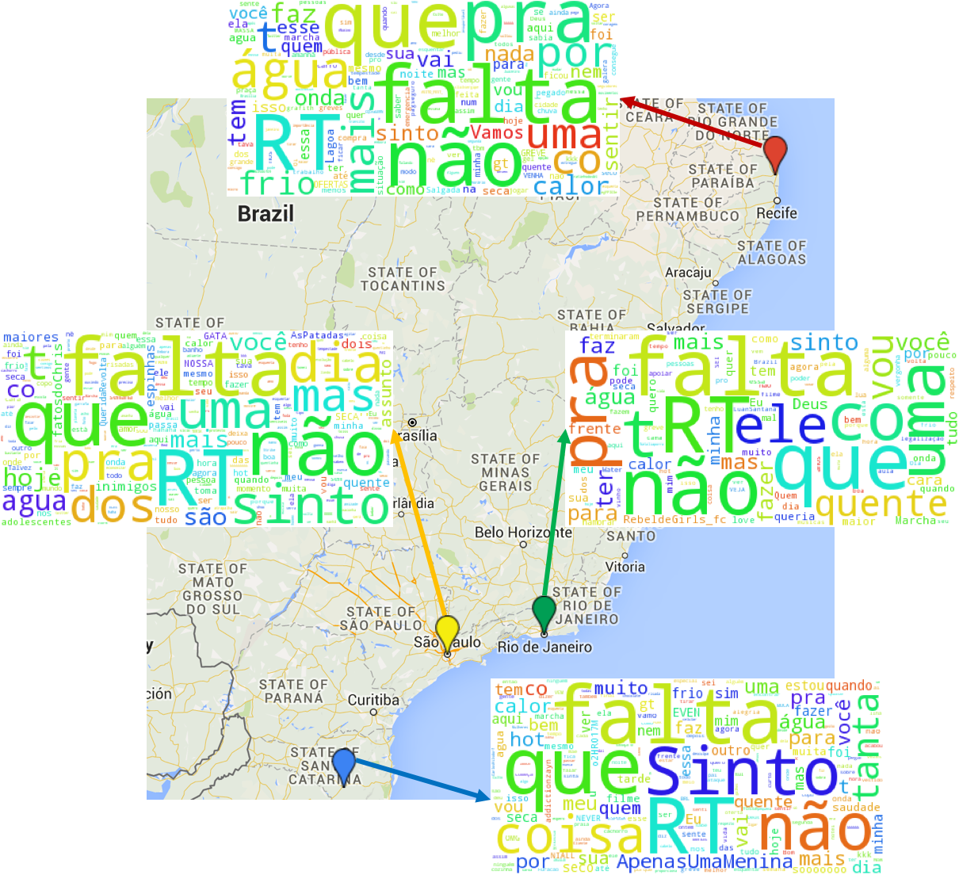

**Figure 15 Brazil Drought Events using Events Clustering**

In order to get more information, we focus on the weather events happened on May 7th, 2012. As we can see in Figure 15, red, green, yellow and blue pin stand for weather events happened at city Bayeux, Rio de Janeiro, São Paulo and Lages, respectively. All these word cloud are dominated by words falta and agua which are words lack and water in Spanish, which are quite conformed with the drought and heat happen in Brazil. With our work, we can detect not only weather and climate events, but also the scope and subjects of these events.

As a matter of fact, in the summer of 2012, almost all the Latin American countries suffered from severe drought. Figure 15a, 15b, 15c, 15d, 15e, 15f, 15g, 15h and 15i show the word cloud of Argentina, Chile, Colombia, Ecuador, El Salvador, México, Paraguay, Uruguay and Venezuela, respectively. All these word cloud are generated from Twitter data of these Latin American countries on May 1st, 2012.

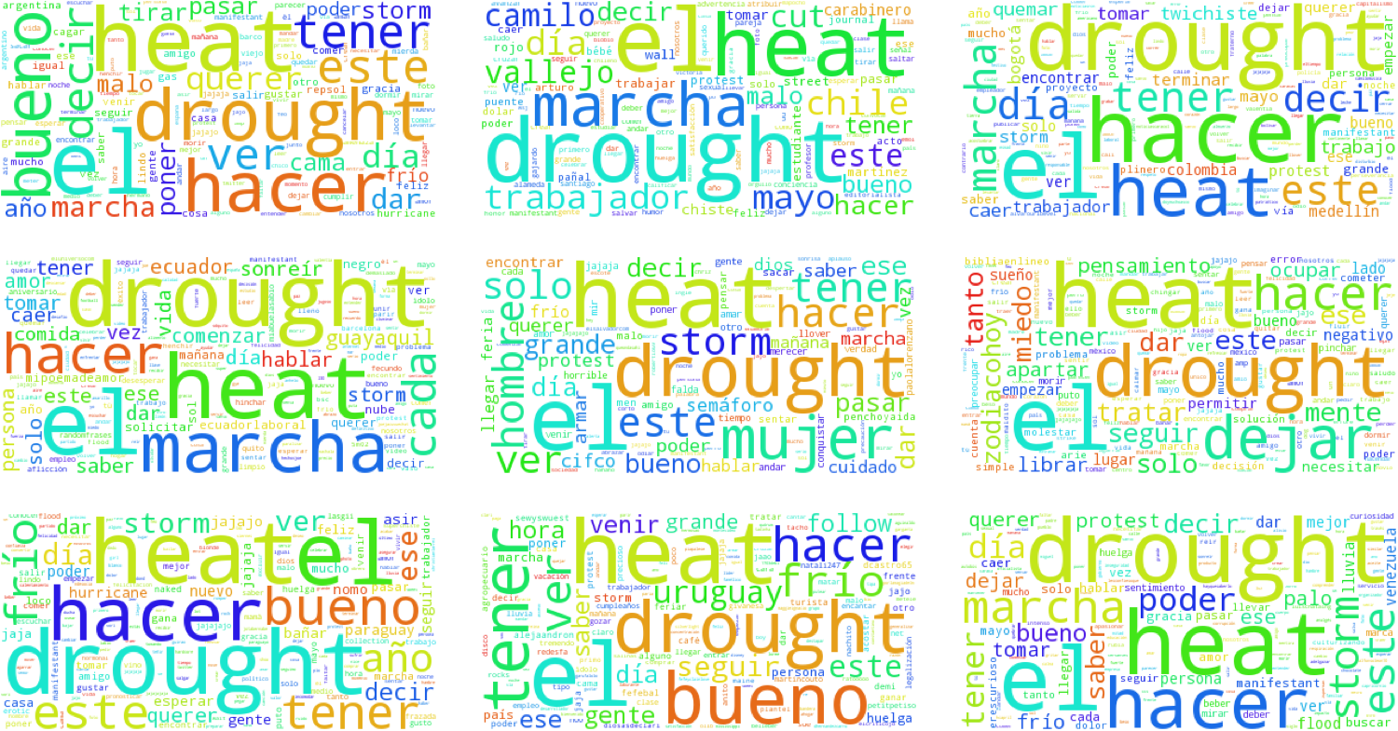

**Figure 16 Word Cloud of Drought in Latin American Countries on May 1st, 2012**

## Case Study 4: Ecuador Drought and Storm, Dec. 2012

As the entire Latin American suffered from severe drought, some interesting thing happened during the drought if we focus on the word cloud of Ecuador in Dec. 2012. Figure 17a, 17b, 17c and 17d show the result of Ecuador from Dec. 1st to Dec. 4th, respectively. In Figure 17, we can see that drought still dominate the topics in Twitter data. However, in Figure 16d, word storm seems inappropriate, so we try to find what happened on Dec. 4th in Ecuador.

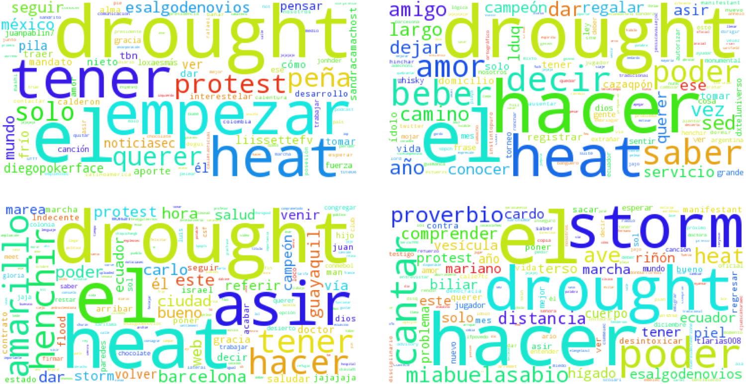

**Figure 17 Word Cloud of Ecuador Drought**

After using the events clustering processing, the storm event was separated from the drought of the whole Ecuador. In Figure 18, word tormenta is the word storm in Spanish, and the storm was happened in the city of Cuenca, which is the capital of the Azuay Province in Ecuador. Therefore, it is reasonable that the word storm mixed in the word cloud on Dec. 4th as we use the Twitter data of entire country before events clustering.

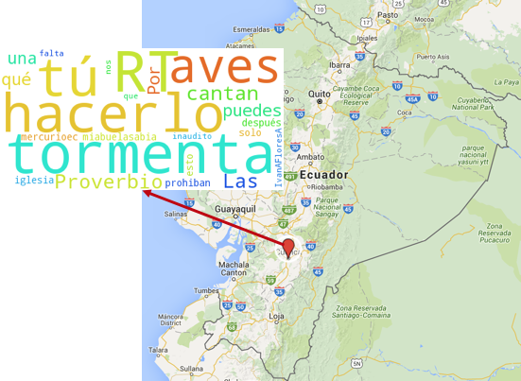

**Figure 18 Storm Event in Ecuador**

## Case Study 5: Argentina Flood, Nov. 2012

High winds, heavy rainfall and flooding reported in Buenos Aires, Argentina on Oct. 29th. A lot of people though these extreme weather was caused by Hurricane Sandy, 2012. In Figure 18, word cloud of Argentina is from Nov. 1st to Nov. 6th, respectively. And on Nov 4th, the word hurricane decreased, and 8n became dominant. Actually, 8n is a hashtag/slogan in Twitter, which is advertised for Nov 8th movement. As the movement is mainly a massive anti-government protest in Argentina, the signal is so strong that disturbing our result.

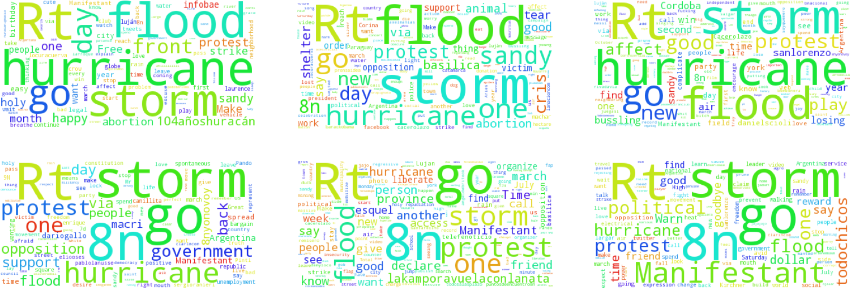

**Figure 19 Word Cloud of Argentina Flood on Nov. 2012**

## Case Study 6: Brazil Heatwave, Feb. 2014

As we said before, Brazil suffered from severe drought recent years. The drought in Brazil is also serious in 2014, as we can seen in Figure 19. In Figure 19, the word heat and drought dominated the topic of Twitter data, which is similar to drought events. However, the different between drought and heatwave is that there are still obvious of civil unrest events, which are shown by the words protest, manifestant etc. It is because when the heatwave strike Brazil, lots of people protest for their own rights. Workers asked for improvement of working environment, and students asked for air conditioner in their schools or universities. While in drought events, people pay more attention on water supply for their daily lives.

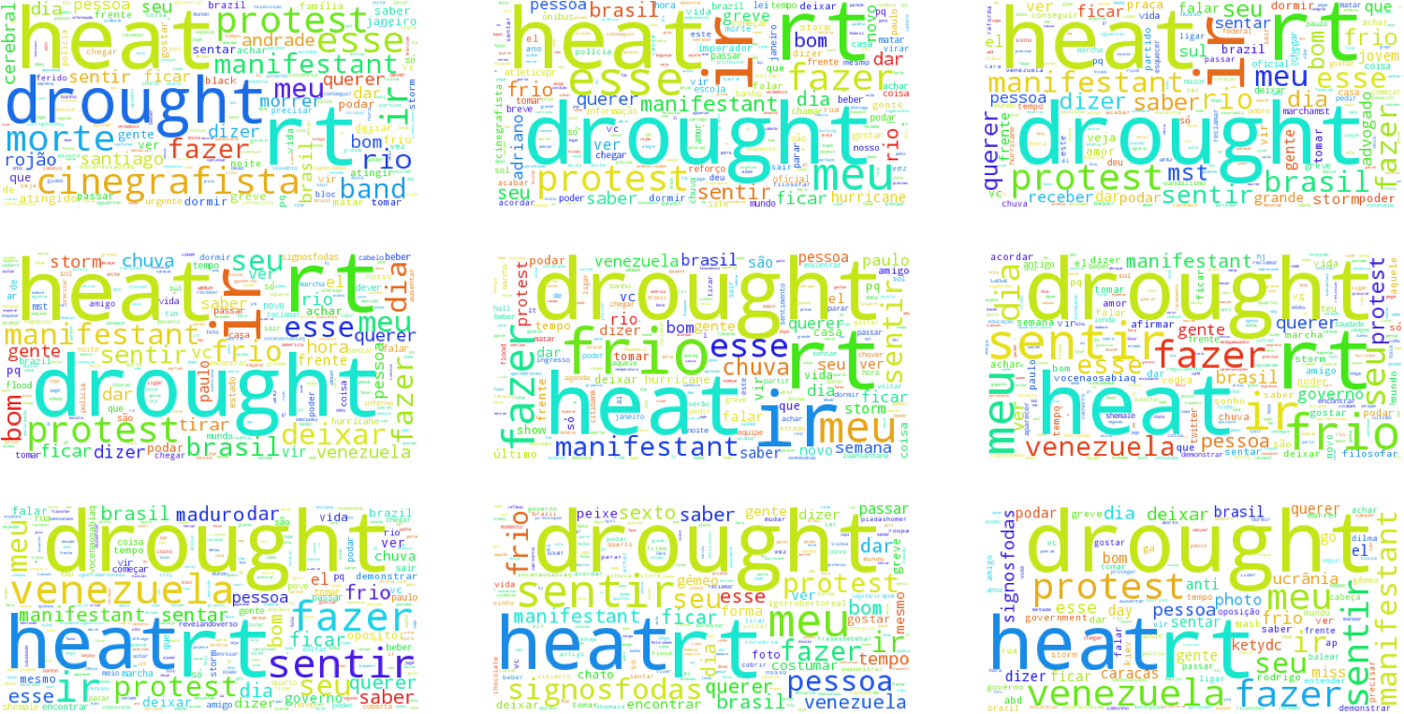

**Figure 20 Word Cloud of Brazil Heatwave on Feb. 2014**

## References

1. Ning, Y., Muthiah, S., Tandon, R., & Ramakrishnan, N. Uncovering News-Twitter Reciprocity via Interaction Patterns.
2. Zhao, L., Chen, F., Dai, J., Hua, T., Lu, C. T., & Ramakrishnan, N. (2014). Unsupervised Spatial Event Detection in Targeted Domains with Applications to Civil Unrest Modeling. PLoS ONE, vol. 9, no. 10, p. e110206, Oct. 2014.
3. Liao, Y., & Vemuri, V. R. (2002, August). Using Text Categorization Techniques for Intrusion Detection. In USENIX Security Symposium (Vol. 12, pp. 51-59).
4. Mihalcea, R., Corley, C., & Strapparava, C. (2006, July). Corpus-based and knowledge-based measures of text semantic similarity. In AAAI (Vol. 6, pp. 775-780).
5. Ramakrishnan, N., Butler, P., Muthiah, S., Self, N., Khandpur, R., Saraf, P., ... & Mares, D. (2014, August). 'Beating the news' with EMBERS: forecasting civil unrest using open source indicators. In Proceedings of the 20th ACM SIGKDD international conference on Knowledge discovery and data mining (pp. 1799-1808). ACM.